

Architecture Definition
Project XXX
Client YYY

<<NB: This document provides a generic template. It may require tailoring to suit a specific client and project situation>>

Table of Contents

1 Document Purpose 5
2 Scope 6
3 Goals, Objectives, and Constraints 7
3.1 Business and Technology Goals 7
3.2 Objectives Derived From the Goals 7
3.3 Stakeholders and Their Concerns 8
3.4 Constraints 9
3.5 Capabilities 9
4 Compliance 10
4.1 Architecture Principles 10
4.2 Policies and Standards 10
5 Risks and Issues 11
5.1 Assumptions 11
5.2 Risks 11
5.3 Issues 11
5.4 Dependencies 12
6 Baseline Architecture 13
6.1 Business Architecture Models 13
6.1.1 Conceptual Baseline Business Architecture 14
6.1.2 Logical Baseline Business Architecture 17
6.1.3 Physical Target Business Architecture 19
6.1.4 Cross References within the Business Architecture 20
6.2 Data Architecture Models 22
6.2.1 Conceptual Baseline Data Architecture 22
6.2.2 Logical Baseline Data Architecture 25
6.2.3 Physical Baseline Data Architecture 27
6.2.4 Baseline Data Architecture Cross References 28
6.3 Application Architecture Models 29
6.3.1 Conceptual Baseline Application Architecture 29
6.3.2 Logical Baseline Application Architecture 31
6.3.3 Physical Baseline Application Architecture 33
6.3.4 Baseline Application Architecture Cross References 33
6.4 Technology Architecture Models 34
6.4.1 Conceptual Baseline Technology Architecture 34
6.4.2 Logical Baseline Technology Architecture 36
6.4.3 Physical Baseline Technology Architecture 37
6.4.4 Baseline Technology Architecture Cross References 38
6.5 Security Architecture Models 38
7 Rationale and Justification for Architectural Approach 39
7.1 Rationale 39
7.2 Approach 39
7.3 Architecture Decisions 39
7.4 Architecture Governance 39
8 Mapping to Architecture Repository 40
8.1 Artefacts 40
8.2 Mapping to Architecture Landscape 41
8.3 Mapping to Reference Models 41
8.4 Mapping to Standards 42
8.5 Re-Use Assessment 42
8.5.1 Use of existing components 43
8.5.2 Opportunities for re-use 43
9 Target Architecture 44
9.1 Business Architecture Models 44
9.1.1 Conceptual Target Business Architecture 45
9.1.2 Logical Target Business Architecture 48
9.1.3 Physical Target Business Architecture 51
9.1.4 Cross References within the Business Architecture 52
9.2 Data Architecture Models 54
9.2.1 Conceptual Target Data Architecture 54
9.2.2 Logical Target Data Architecture 57
9.2.3 Physical Target Data Architecture 58
9.2.4 Target Data Architecture Cross Reference 59
9.3 Application Architecture Models 60
9.3.1 Conceptual Target Application Architecture 60
9.3.2 Logical Target Application Architecture 62
9.3.3 Physical Target Application Architecture 64
9.3.4 Target Application Architecture Cross Reference 64
9.4 Technology Architecture Models 66
9.4.1 Conceptual Target Technology Architecture 67
9.4.2 Logical Target Technology Architecture 68
9.4.3 Physical Target Technology Architecture 70
9.4.4 Target Technology Architecture Cross Reference 70
9.5 Security Architecture Models 71
10 Gap Analysis 72
11 Impact Assessment 74
11.1 Reference to Specific Requirements 74
11.2 Stakeholder Priority of the Requirements to Date 74
11.3 Phases to be Revisited 74
11.4 Conclusions 74
11.5 Recommendations 74

Document Information
Project Name: | Project XXX
Prepared By: |  | Document Version No: | 0.1
Title: | Architecture Definition | Document Version Date:
Reviewed By: |  | Review Date:
Distribution List
From | Date | Phone/Fax/Email

To | Action* | Due Date | Phone/Fax/Email
* Action Types: Approve, Review, Inform, File, Action Required, Attend Meeting, Other (please specify)
Document Version History
Ver. No. | Ver. Date | Revised By | Description | Filename

Document Purpose

< This document packages the baseline, target, and gap analysis for <insert>.

The Architecture Definition Document is the deliverable container for the core architectural artifacts created during a project. The Architecture Definition Document spans all architecture domains (business, data, application, and technology) and also examines all relevant states of the architecture (baseline, interim state(s), and target).
The Architecture Definition Document is a companion to the Architecture Requirements Specification, with a complementary objective:
- The Architecture Definition Document provides a qualitative view of the solution and aims to communicate the intent of the architects.
- The Architecture Requirements Specification provides a quantitative view of the solution, stating measurable criteria that must be met during the implementation of the architecture.

It is suggested that this document reference the various deliverables in the container. For instance, the Architecture Principles will be documented in an Architecture Principles document and that document referenced here. It may be that this container is implemented using a wiki or as an intranet rather than a text-based document. Even better would be to use a licensed TOGAF tool that captures this output.
This template shows “typical” contents of an Architecture Definition Document and can be adapted to align with any TOGAF adaptation being implemented. >

Scope
< The purpose of this Scope sub-section is to outline the scope of the architecture for the domains as well as the scope of this document.
In terms of quality criteria, this section should make clear:
- Parts of the architecture which are in scope;
- Parts of the architecture which are out of scope;
- Parts of the architecture which are in scope for this document. The scope may be the entire architecture within a domain, or a subset of the architecture within a domain;
- Parts of the architecture which are out of scope for this document.

Description | Scope can have many attributes, not all of which will always be required and can be regarded as optional and circumstance dependent. The scope statement details the architecture deliverables, helps describes the major objectives and describes the boundaries of the architecture.  As a baseline, scope statements must contain:  - The architecture sponsors, and stakeholders  - A statement of requirements  - The architecture goals and objectives  - The architecture non-goals (what is out of scope)  - The business processes, locations and organisations (e.g. Business areas) within scope  - The constraints, limitations and boundaries  Additional scope descriptions may exist in other documents (e.g the project brief and P.I.D) and can potentially be referenced here. Examples include:  - The project name;  - The project charter;  - Milestones;  - Cost estimates.
Guidance | (Part of) the scope can be clarified with a Context Diagram  Many of the attributes of a baseline Statement of Scope will exist elsewhere in an architecture deliverable (e.g. Architecture Objectives, Context, Constraint etc.) and can be referenced in preference to repetition where it is appropriate. It is not appropriate to reference in such a way if it can confuse (e.g. reference to a list of 20 constraints when only 5 of them help define the scope) and a separate View should be created.  References to other documents, even documents within the same project, may not be beneficial and, as above, it is often better to repeat information to ensure that the architecture scope is clearly and completely defined in one easily consumed View.
>
Reference-ID | Title | Scope

Goals, Objectives, and Constraints

<The purpose of this Goals/Objectives/Constraints sub-section is to outline the architectural goals, objectives and constraints for the architecture and this document.

In terms of quality criteria, this section should make clear:
- High-level business and technology goals that are driving this exercise and thus which this business architecture and document are meant to help achieve;
- Precise objectives (derived from the goals) that are driving this exercise and thus which this business architecture and document are meant to help achieve;
- Business or technology constraints that need to be taken into consideration as they may influence the decisions made when defining the business architecture;
- Other constraints that need to be taken into consideration as they may impact the delivery (e.g. timescales) of this document and thus exercise.>

Business and Technology Goals

<The purpose of this Business and technology goals sub-section is to outline the business and technology goals for the business architecture and this document.
In terms of quality criteria, this section should make clear:
  - High-level business and technology goals that are driving this exercise and thus which this business architecture and document are meant to help achieve;

Objectives Derived From the Goals

<The purpose of this Objectives derived from the goals sub-section is to outline the objectives for the business architecture and this document.
In terms of quality criteria, this section should make clear:
a. Precise objectives (derived from the goals) that are driving this exercise and thus which this business architecture and document are meant to help achieve;

<
Concern | Does the architect understand what I (sponsor) want to be able to do with the architecture?
Description | There are two classes of Architecture Objective. There are objectives which are aligned to the project delivery, for which the Project Manager and the Sponsor are key owners. There are also objectives which are aligned to broader strategic and enterprise goals, for which the IMS Strategy & Architecture is a key owner.  A View of both classes enables the understanding of strategic versus project deliverables.  In the first class are:  - Ensure the optimum approach to achieving the project goals;  - Reduce project costs through the adoption of appropriate products and services;  - Alignment with the Design Authority.  In the second class are:  - Alignment with the Business Mission and Strategy;  - Alignment with Business Partners and (other Business areas  - Ensure consistency across all delivery projects in the organisation;  - Reduce costs through the adoption of standards.
Guidance | This View is a simple selection of the architecture objectives or strategies as appropriate. See the architecture objectives artefact template

Reference-ID | Title | Class | Architecture Objective/Strategy description

<May reference the business goals and drivers documentation.>

Stakeholders and Their Concerns

<The purpose of this Stakeholder and their concerns sub-section is to identify the stakeholders for the business architecture and this document.
In terms of quality criteria, this section should make clear:
- The RACI (Responsible, Accountable, Consulted, Informed) stakeholders for the business architecture and this document:
  - Responsible – stakeholders are those that undertake the exercise/action i.e. do the work;
  - Accountable – stakeholders are those that own the exercise/deliverable. Only one stakeholder should be accountable for an exercise/deliverable. They may own the budget (i.e. purse strings) and/or have overall management responsibility for the exercise/deliverable;
  - Consulted – stakeholders are those from whom input is gathered in order to produce the deliverable. They tend to be subject matter experts in specific business areas or technologies;
  - Informed – stakeholders are those to whom the deliverable is distributed as they tend to have a dependency on its content;
- Stakeholders who need to review the business architecture and this document;
- Stakeholders who need to approve the business architecture and this document;
- Decision making stakeholders in terms of governance and management such as scope confirmation, issue escalation, and issue resolution (if not already defined elsewhere, for example, in a project initiation document (PID));
- Concerns of these stakeholders with regards to the business architecture or this exercise;
- Issues of these stakeholders with regards to the business architecture or this exercise.>

Constraints

<

Concern | Do the constraints represent the agreed limitations?  Are they stated clearly and in such a way that design decisions can be made appropriately?
Description | A constraint is a basic rule or statement that MUST be followed to ensure that the organizational and IT strategy/aspirations and the architectural objectives can be met. Constraints are similar to Principles but they have no weighting. Constraints cannot be violated, they must all be met, so there cannot be a trade-off mechanism to evaluate conflicting Constraints. If the Constraints conflict then a solution alternative or a design decision is not possible and the constraints must be revisited to identify if any can be removed.
Guidance | Constraints must be unambiguous and have certain attributes. This View is a simple selection of the architecture constraints. See the architecture constraints artefact template for a list of attributes.
>

Reference-ID | Title | Architecture Constraint | Priority | Consequences

Capabilities
<The purpose of this Capabilities sub-section is to identify the capabilities <The Client> needs to have to achieve their business goals. Capabilities include both business services and application services.
In terms of quality criteria, this section should make clear:
- The capabilities and their descriptions;
- The priority of the capabilities in a list.>

Compliance

Architecture Principles

<May reference the architecture principles documentation

Concern | Do the principles represent the agreed decision criteria?  Are they stated clearly and in such a way that design decisions can be made appropriately?
Description | A principle is a basic rule or statement that should be followed to ensure that the organizational and IT strategy/aspirations and the architectural objectives can be met. Principles give direction to the choices and solution directions that are applicable. They make the arguments and decisions more explicit and traceable, so they are a guide in decision making and an aid for structuring services. Principles may contradict and priorities need to be set for them.
Guidance | Principles must be unambiguous and have certain attributes. This View is a simple selection of the architecture principles. See the architecture principles artefact template for a list of attributes.

Name | <Name of Principle>
Principle Reference | <Unique identifier for the principle.>
Statement | The Statement should succinctly and unambiguously communicate the fundamental rule. For the most part, the principles statements for managing information are similar from one organization to the next. It is vital that the principles statement be unambiguous.
Rationale | The Rationale should highlight the business benefits of adhering to the principle, using business terminology. Point to the similarity of information and technology principles to the principles governing business operations. Also describe the relationship to other principles, and the intentions regarding a balanced interpretation. Describe situations where one principle would be given precedence or carry more weight than another for making a decision.
Implications | The Implications should highlight the requirements, both for the business and IT, for carrying out the principle – in terms of resources, costs, and activities/tasks. It will often be apparent that current systems, standards, or practices would be incongruent with the principle upon adoption. The impact to the business and consequences of adopting a principle should be clearly stated. The reader should readily discern the answer to: “How does this affect me?” It is important not to oversimplify, trivialize, or judge the merit of the impact. Some of the implications will be identified as potential impacts only, and may be speculative rather than fully analyzed.
>

Policies and Standards

Risks and Issues

Assumptions
ID | Assumption Item | Description | Date | Source | Owner

Risks

<
Concern | Are the risks clearly described and communicated?  Do agreed mitigations exist for all stated risks?
Description | A risk is a description of an issue or problem that may arise related to the architecture development. Risks that are related to the architecture result are mandatory here, project risks are out of scope.  A risk that has arisen or been realised must be described as an issue (for the project) and/or a constraint (within the architecture as an artefact).
Guidance | This View is a simple selection of the architecture risks.  The number of risks being documented within the architecture should reduce during the lifetime of an architecture project.
>

Reference-id | Title | Description | Impact | Measures | Mitigation Plan

Issues

ID | Issue | Status | Input Date | Due Date | Closed Date | Owner | Work Group Owner | Meeting Notes/Comments

Dependencies
Reference-id | Title | Description | Impact | Measures | Comment

Baseline Architecture

Business Architecture Models
<The purpose of this Current Business Architecture section is to define the current business architecture that is in scope for this exercise.

Note: This section may be refined once the business architecture team has been set up.

Note 2: The level of granularity at which the artefacts need to be defined is dependant on the level of detail that is required from the business architecture, and thus is a decision for the individual domains.

Mandatory/optional: This section is optional as the domain may only wish to produce a target business architecture. Also, a degree of flexibility exists when documenting each of the sub-sections within this section. The domain only needs to produce the relevant artifacts from those highlighted in this section as per their needs. They do not need to produce all the artifacts, views, tables etc. presented in this section.

In terms of quality criteria, this section may make clear:
- Any other relevant business architecture documentation;
- Context around any such relevant business architecture documentation e.g. validity, ownership, purpose;
- Any assumptions regarding the business architecture documentation.
- Relevant views (diagrams) illustrating the business functions in scope for the current business architecture;
- Description of the business function view(s);
- Definitions for the business functions (in table format) in scope for the current business architecture;
- Relevant views (diagrams) illustrating the organisation structure and units in scope for the current business architecture;
- Description of the organisation structure and units view(s);
- Definitions for the organisation structure and units (in table format) in scope for the current business architecture;
- Relevant views (diagrams) at the conceptual level illustrating the conceptual business services and their contracts (interactions) in scope for the current business architecture;
- Description of the conceptual level view(s) in order to understand the architectural decisions that have been taken and resulting key messages for the stakeholders;
- Definitions for the conceptual business services (in table format) in scope for the current business architecture;
- Characteristics of the conceptual business services (in table format) in scope for the current business architecture;
- Descriptions of the contracts (interactions) between the conceptual business services (in table format) in scope for the current business architecture;
- If required, characteristics of the contracts (interactions) between the business services (in table format) in scope for the current business architecture;
- Relevant views (diagrams) at the logical level illustrating the business processes in scope for the current business architecture;
- Description of the logical level view(s) in order to understand the architectural decisions that have been taken and resulting key messages for the stakeholders;
- Definitions for the business processes (in table format) in scope for the current business architecture;
- Any relationships between the business function categories, business functions, business service categories and business services that are in scope for the current business architecture;
- Any assumptions that have been used to define the current business architecture.>

Conceptual Baseline Business Architecture

Baseline Business Functions
<Business Architecture Function View Example: This sub-section needs to provide one or more business function views for the baseline business architecture. The diagram below provides a view of the baseline business function categories and business functions. This particular example illustrates some of the possible business function categories and business functions. However, the definition of business function categories and business functions can only be confirmed during the architectural analysis for each domain. Text describing the key concepts and notation used within the diagram will also need to be included so that users can easily read and understand the view.
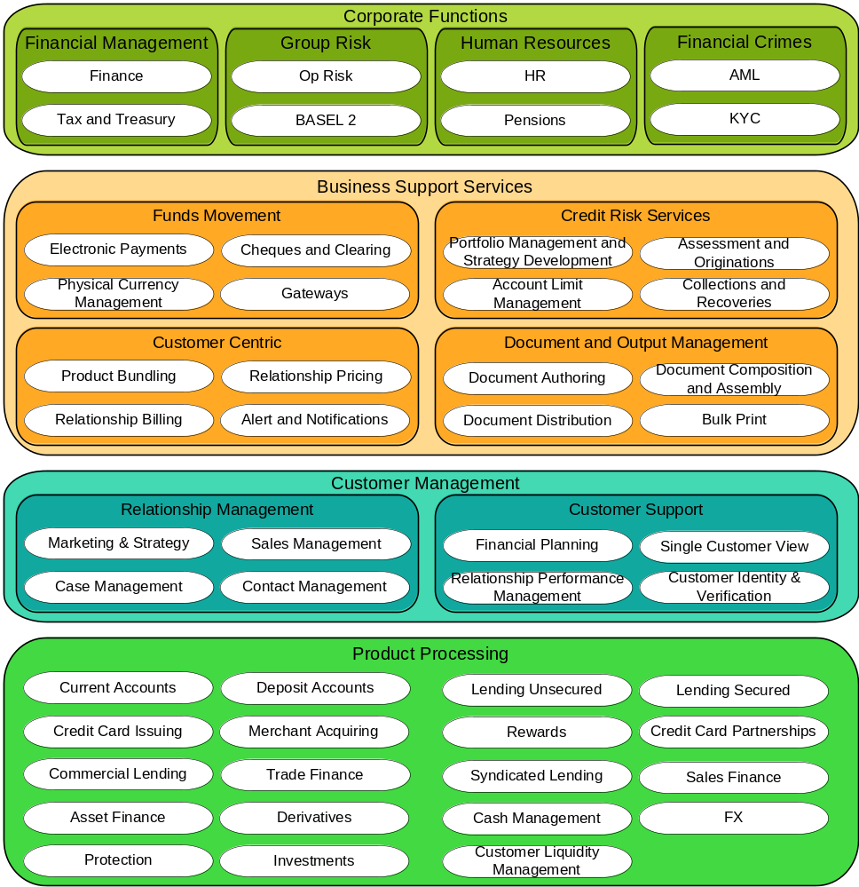

>
<Business Architecture Function View Description: This sub-section needs to provide a description of the business function view(s) for the baseline business architecture in order to understand the key messages for the stakeholders.>
<Business Architecture Function Definitions: This sub-section needs to provide (in table format) definitions for the business function categories and business functions in scope for the baseline business architecture.>

Business Function (Category) Id | Business Function Category | Business Function | Business Function Description

Baseline Business Services
<Business Architecture Conceptual Level View Example: This sub-section needs to provide one or more conceptual level views for the current business architecture. The diagram below provides a view of the current business architecture at the conceptual level which consists of business services categories and business services. This particular example illustrates some of the business services within XXXX. However, the definition of business services can only be confirmed during the architectural analysis for each domain. Text describing the key concepts and notation used within the diagram will also need to be included so that users can easily read and understand the view.
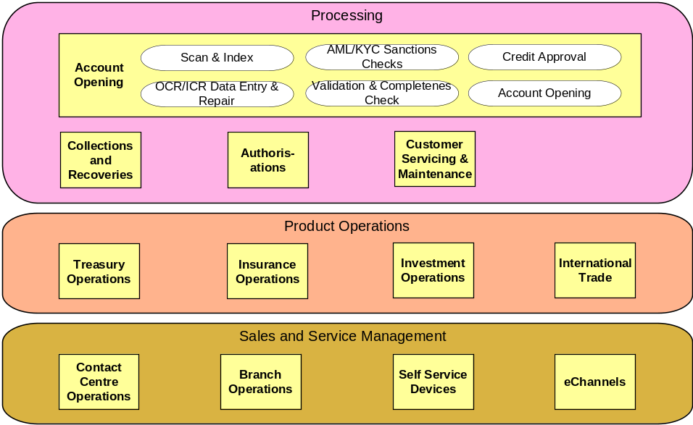
>
<Business Architecture Conceptual Level View Description: This sub-section needs to provide a description of the conceptual level view(s) for the current business architecture in order to understand the architectural decisions that have been taken and resulting key messages for the stakeholders.>

<Business Architecture Conceptual Level Artifact Definitions: This sub-section needs to provide (in table format) definitions for the business service categories and business services in scope for the current business architecture.>

Business Service (Category) Id | Business Service Category | Business Service | Business Service Description
<Business Architecture Conceptual Level Artifact Characteristics: This sub-section may provide (in table format) characteristics for the business services in scope for the current business architecture.>

Business Service | Business Service Characteristic | Business Service Characteristic Value

<Business Architecture Conceptual Level Artifact Contracts: This sub-section may provide (in table format) descriptions of the contracts (i.e. interactions/relationships) between the business services in scope for the current business architecture.>

BS Contract Id | Business Service Contract | Business Service 1 | Business Service 2 | Business Service Contract Description

<Business Architecture Conceptual Level Artifact Contract Characteristics: This sub-section may provide (in table format) characteristics of the contracts (i.e. interactions/relationships) between the business services in scope for the current business architecture. The domain needs to determine which characteristics they wish to capture.>

Business Service Contract | Business Service Contract Characteristic | Business Service Contract Characteristic Value

Business Service Security Classification View
< Business Service Security Classification View Example: This sub-section may provide one or more views of security classification for the baseline business services.>

< Business Service Security Classification View Description: Business Services have attributes that can describe various functional and non-functional aspects. Among these attributes is the security classification. The context within which a Business Service operates can be derived from the Information Objects, as these objects can have a CIA classification.
The definition of the Business Service security should be carried out before a project is initiated as part of a Business Impact Analysis.
Project architecture documents must take the security classifications of the artefacts that will be impacted by the project and ensure both that the intended solution is using appropriately secure artefacts and that it will not have a negative impact on the security of those artefacts. >
Reference-id* | Title* | Subject | Confidentiality Classification | Integrity Classification | Availability Classification

Organisation Structure and Units
<Business Architecture Organisation View Example: This sub-section may provide one or more views of organisational structure and units for the baseline business architecture.
<Business Architecture Organisation View Description: This sub-section needs to provide a description of the organisational structure and units view(s) for the baseline business architecture in order to understand the key messages for the stakeholders.>
<Business Architecture Organisation Definitions: This sub-section needs to provide (in table format) definitions for the organisational structure and units in scope for the baseline business architecture.>

Organisation Unit Id | Organisation Unit | Organisation Unit Parent | Organisation Unit Description

User Satisfaction
<Business Architecture Services User Satisfaction: This sub-section provides a view of current user satisfaction rates for the services. It contains detailed information about complaints and positive features of the current services.>

Business Service | User Satisfaction (Scale 1-10) | Notes, Specific Issues

Roles
<The purpose of this Roles section is to describe the roles in the baseline architecture.
Mandatory/optional: This section is optional.
In terms of quality criteria, this section should make clear:
- Human (system) roles in the baseline architecture;
- Computer (system) roles in the baseline architecture.>

Logical Baseline Business Architecture

Actors
<The purpose of this Actors section is to describe the system users/actors in scope for the target architecture. System actors/users are those users who interact with a system. They can be human or a system/computer.
Mandatory/optional: This section is optional.
In terms of quality criteria, this section should make clear:
- Human (system) actors in scope for the baseline architecture;
- Computer (system) actors in scope for baseline architecture;
- Any other system actor oriented requirements in scope for the target architecture.>

Human Actors
<The purpose of this Human Actors sub-section is to define the human actors in scope for the target architecture.
Mandatory/optional: This sub-section is optional.
In terms of quality criteria, this sub-section should make clear:
- Human actors in scope for the target architecture.>

Computer Actors
<The purpose of this Computer Actors sub-section is to define the computer actors in scope for target architecture.
Mandatory/optional: This sub-section is optional.

In terms of quality criteria, this sub-section should make clear:
- Computer actors and roles in scope for target architecture.>

Actor  Business role | Actor 1 | Actor 2 | Actor 3
Role 1 | X
Role 2
Role 3
Role 4

Other Requirements
<The purpose of Other Requirements sub-section is to define any other actor oriented requirements in scope for the target architecture.
Mandatory/optional: This sub-section is optional.
In terms of quality criteria, this sub-section should make clear:
- Any other actor oriented requirements in scope for the target architecture.>

Baseline Business Architecture (Processes)
<Business Architecture Process View Example: This sub-section may provide one or more logical level views for the baseline business architecture. These views will illustrate the business processes in the baseline business architecture. Text describing the key concepts and notation used within the diagram(s) will also need to be included so that users can easily read and understand the view.>

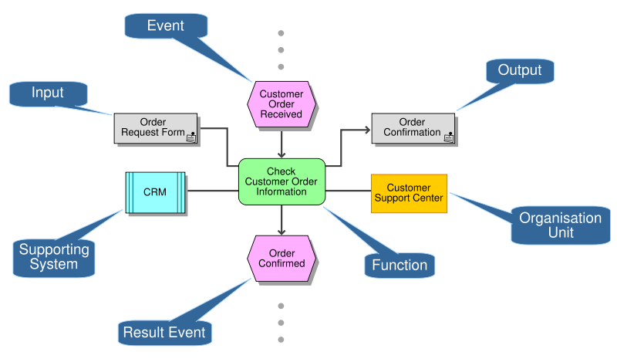
<Business Architecture Process View Description: This sub-section may provide a description of the business process view(s) in scope for the baseline business architecture in order to understand the key messages for the stakeholders.>

<Business Architecture Process Definitions: This sub-section may provide (in table format) definitions for the business processes in scope for the baseline business architecture.>

Logical Business Top Level View
< Logical Business Top Level View Example: This sub-section may provide one or more top-level logical views for the target business architecture.

< Logical Business Top Level View Description:
Concern What are the highest level structuring principles we have to obey?
Description Defines and shows the highest aggregation level to be used for the business architecture, often the business domains, based on a high level structuring of services delivered to the outside world by the business. Often 1 level more detailed than the context diagram.
Guidance This view helps ensure correct Sponsor communication of the architecture. It demonstrates the products and / or services that the business is delivering to the customers grouped per business domain. This is often 1 level more detailed than the context diagram. >

Physical Target Business Architecture

Process Allocation
< Key locations can be represented geographically, functionally or structurally. The choice of representation depends on the key point(s) of the model. A text based template is provided. >

Location  Physical process | Location 1 | Location 2 | Location 3
Process 1 | X
Process 2
Process 3
Process 4

Physical Business Component RACI View
< View that demonstrates the accountability and responsibility of physical business components, containing business services by Business areas or other external Organizational units.
The presented Information can be very sensitive. This scope and circulation of this view must be agreed in advance. >
 | Business Unit  Actors |  |  | 3rd Party  Actors | Implementation  Actors
Activity | Actor 1 | Actor 2 | Actor 3 | Actor 4 | Actor 5 | Actor 6 | Actor 7
Activity 1 | AR | C
Activity 2 | AR | C |  |  | C | C | I
Activity 3 | A | C |  |  | R | I
Activity 4 |  |  |  |  | AR
Activity 5 | R | C | A | I | C
Activity 6 | C | C | I |  | C | AR | I

Role/Actor Allocation
< The assignment of roles and responsibilities to staff is a very sensitive issue. For this reason this View is rarely included within an architecture document, but it is sometimes required as an additional View that will be circulated under a separate cover. Such Views will always require the involvement of the HR department and senior managers and such stakeholders are often the sponsors for the extra document that contains the View. >

Staff type  Physical process | Staff type 1 | Staff type 2 | Staff type 3
Actor / role 1 | X
Actor / role 2
Actor / role 3
Actor / role 4

Physical Organisation Model
< The creation of a physical organisational model is a very sensitive issue. For this reason this View is rarely included within an architecture document, but it is sometimes required as an additional View that will be circulated under a separate cover. Such Views will always require the involvement of the HR department and senior managers and such stakeholders are often the sponsors for the additional documentation.>

Cross References within the Business Architecture
<Business Architecture Cross References Example: This sub-section may populate the spreadsheet below which enables the definitions and relationships between business function categories, business functions, business service categories, business services to be captured and documented.

Business Function & Service Descriptions
Business Function Category | Business Function | Business Service Group | Business Service
<Business Function Category Name> | <Business Function Description>
 | <Business Function Name> | <Business Function Description>
 |  | <Business Service Category Name> | <Business Service Category Description>
 |  |  | <Business Service Name> | <Business Service Description>
 |  |  | <Business Service Name> | <Business Service Description>
 |  |  | <Business Service Name> | <Business Service Description>

>

Data Architecture Models
< The purpose of this Baseline Data architecture sub-section is to define the baseline Data architecture for the domain/sub-domain.
Mandatory/optional: This sub-section is optional. The data domain team will only produce a detailed set of target Data architecture documentation at the planning, conceptual and logical levels. Thus the relevant domain only needs to produce relevant artifacts from those highlighted in this section as per their needs.
In terms of quality criteria, this sub-section may make clear:
- Relevant views (diagrams) at the planning level illustrating the information subject areas in scope for the baseline Data architecture, as well as the relationships between them;
- Description of the planning level view(s) for the baseline Data architecture in order to understand the architectural decisions that have been taken and resulting key messages for the stakeholders;
- Definitions for the information subject areas (in table format) in scope for the baseline Data architecture;
- Descriptions of the relationships and cardinality (if relevant) between the information subject areas (in table format) in scope for the baseline Data architecture;
- Relevant views (diagrams) at the conceptual level illustrating the business objects in scope for the baseline Data architecture, as well as the relationships between them. These medium-level business objects will have been derived from the high-level information subject areas;
- Description of the conceptual level view(s) for the baseline Data architecture in order to understand the architectural decisions that have been taken and resulting key messages for the stakeholders;
- Definitions for the business objects (in table format) in scope for the baseline Data architecture;
- Descriptions of the relationships and cardinality (if relevant) between the business objects (in table format) in scope for the baseline Data architecture;
- Relevant views (diagrams) at the logical level illustrating the logical data entities in scope for the baseline Data architecture, as well as the relationships between them. These lower-level logical data entities will have been derived from the medium-level business objects;
- Description of the logical level view(s) for the baseline Data architecture in order to understand the architectural decisions that have been taken and resulting key messages for the stakeholders;
- Definitions for the logical data entities (in table format) in scope for the baseline Data architecture;
- Characteristics of the logical data entities (in table format) in scope for the baseline Data architecture;
- Descriptions of the relationships and cardinality (if relevant) between the logical data entities (in table format) in scope for the baseline Data architecture;
- Any additional viewpoints and thus views that are required for this section due to new stakeholder requirements. These views will then be followed by descriptions for the views and definitions for the view artifacts;
- Any assumptions that have been used to define the baseline Data architecture.>

Conceptual Baseline Data Architecture

<Data architecture Planning Level View Example: This sub-section may provide one or more planning level views for the baseline Data architecture. The diagram below provides a view of the baseline Data architecture at the planning level which consists of information subject areas and the relationships between them. The view also shows the decomposition of information subject areas into business objects. This particular example illustrates some example information subject areas. Text describing the key concepts and notation used within the diagram will also need to be included so that users can easily read and understand the view.>

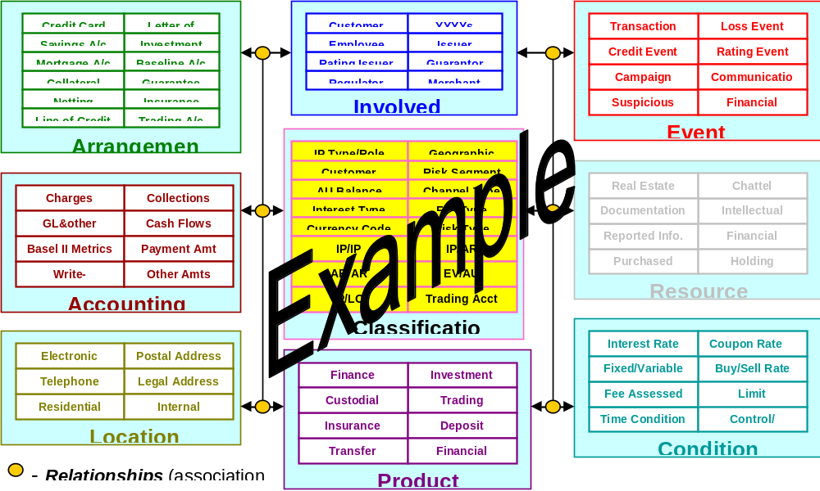

<Data architecture Planning Level View Description: This sub-section may provide a description of the planning level view(s) for the baseline Data architecture in order to understand the architectural decisions that have been taken and resulting key messages for the stakeholders.>

<Data architecture Planning Level Artifact Definitions: This sub-section may provide (in table format) definitions for the information subject areas in scope for the baseline Data architecture.>

Information Subject Area Id | Information Subject Area | Information Subject Area Description

<Data architecture Planning Level Artifact Relationships: This sub-section may provide (in table format) definitions and cardinality for the relationships between the information subject areas in scope for the baseline Data architecture.>

ISA Relationship Id | Information Subject Area 1 | Information Subject Area 2 | Information Subject Area Cardinality | Information Subject Area Relationship Description

<Data architecture Conceptual Level View Example: This sub-section may provide one or more conceptual level views for the baseline Data architecture. The diagram below provides a view of the baseline Data architecture at the conceptual level which consists of business objects and the relationships between them. This particular example illustrates the business objects within the Marketing information subject area. Text describing the key concepts and notation used within the diagram will also need to be included so that users can easily read and understand the view.>

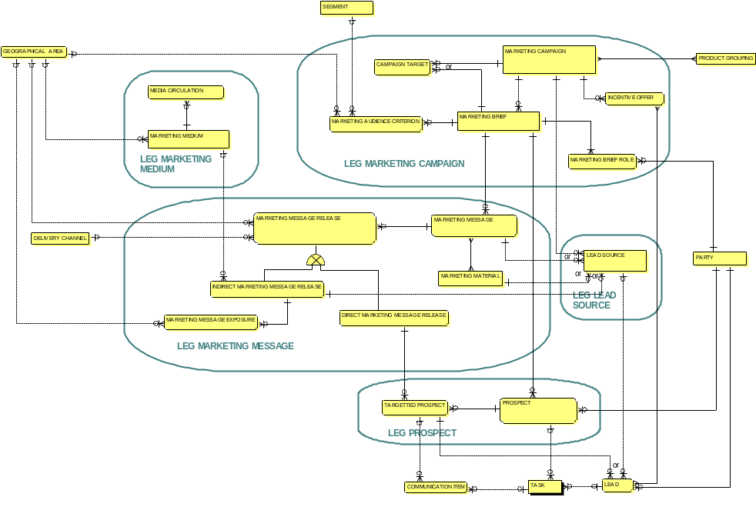

<Data architecture Conceptual Level View Description: This sub-section may provide a description of the conceptual level view(s) for the baseline Data architecture in order to understand the architectural decisions that have been taken and resulting key messages for the stakeholders.>

<Data architecture Conceptual Level Artifact Definitions: This sub-section may provide (in table format) definitions for the business objects in scope for the baseline Data architecture. An optional attribute is information classification. With this attribute it is possible to classify the business objects.>

Business Object Id | Business Object | Business Object Description

<Data architecture Conceptual Level Artifact Relationships: This sub-section may provide (in table format) definitions and cardinality for the relationships between the business objects in scope for the baseline Data architecture.>

BO Relationship Id | Business Object 1 | Business Object 2 | Business Object Cardinality | Business Object Relationship Description

User Satisfaction
<Data Architecture Services User Satisfaction: This sub-section provides a view of current user satisfaction rates for the subject areas. It contains detailed information about complaints and positive features of the current subject areas.>

Information Subject Area | User Satisfaction (Scale 1-10) | Notes, Specific Issues

Data Service Security Classification View
< Data Service Security Classification View Example: This sub-section may provide one or more views of security classification for the baseline data services.>

< Data Service Security Classification View Description: Data Services have attributes that can describe various functional and non-functional aspects. Among these attributes is the security classification. The context within which a Data Service operates can be derived from the Information Objects, as these objects can have a classification.
The definition of the Data Service security should be carried out before a project is initiated as part of a Data Impact Analysis.
Project architecture documents must take the security classifications of the artefacts that will be impacted by the project and ensure both that the intended solution is using appropriately secure artefacts and that it will not have a negative impact on the security of those artefacts. >
Reference-id* com-ponent | Title* component | Reference-id* | Title* | Subject | Confidentiality Classification | Integrity Classification | Availability Classification

Logical Baseline Data Architecture
<Data architecture Logical Level View Example: This sub-section may provide one or more logical level views for the baseline Data architecture. The diagram below provides an example view of the baseline Data architecture at the logical level which consists of logical data entities and the relationships between them. This particular example illustrates the logical data entities derived from the Customer business object. Text describing the key concepts and notation used within the diagram will also need to be included so that users can easily read and understand the view.>

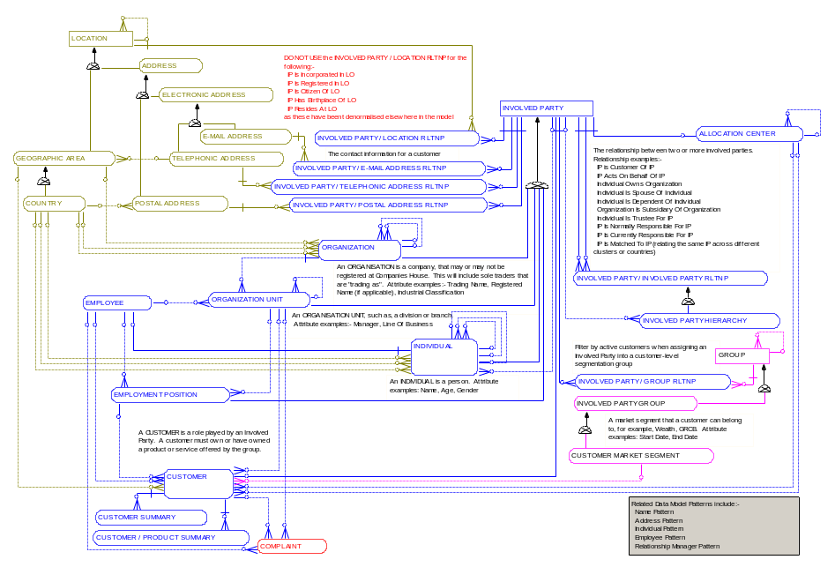

<Data architecture Logical Level View Description: This sub-section may provide a description of the logical level view(s) for the baseline Data architecture in order to understand the architectural decisions that have been taken and resulting key messages for the stakeholders.>

<Data architecture Logical Level Artifact Definitions: This sub-section may provide (in table format) definitions for the logical data entities in scope for the baseline Data architecture.>

Logical Data Entity Id | Logical Data Entity | Logical Data Entity Description

<Data architecture Logical Level Artifact Characteristics: This sub-section may provide (in table format) characteristics for the logical data entities in scope for the baseline Data architecture. The domain needs to determine which characteristics they wish to capture.>

Logical Data Entity | Logical Data Entity Characteristic | Logical Data Entity Characteristic Value

<Data architecture Logical Level Artifact Attribute Definitions: This sub-section may provide (in table format) definitions for the attributes of the logical data entities in scope for the baseline Data architecture. A separate table may be produced per logical data entity. An optional attribute is information classification. With this attribute it is possible to classify the Logical Data Entities.>

Logical Data Entity | Logical Data Entity Attribute | Logical Data Entity Attribute Description

<Data architecture Logical Level Artifact Relationships: This sub-section may provide (in table format) definitions and cardinality for the relationships between the logical data entities in scope for the baseline Data architecture.>

LDE Relationship Id | Logical Data Entity 1 | Logical Data Entity 2 | Logical Data Entity Cardinality | Logical Data Entity Relationship Description

Physical Baseline Data Architecture
< This section describes the interaction between data models that cross ownership boundaries.>

<Data architecture Physical Level View Example: This sub-section may provide one or more logical level views for the baseline Data architecture. The diagram below provides an example view of the baseline Data architecture at the physical level which consists of physical data entities and the relationships between them. This particular example illustrates the physical instance of a logical data entities derived from the Customer business object. Text describing the key concepts and notation used within the diagram will also need to be included so that users can easily read and understand the view.
Determine the interaction between the data entities, select and visualize the interactions that cross logical ownership boundaries. Determine the impact of information ownership on these interactions.
>
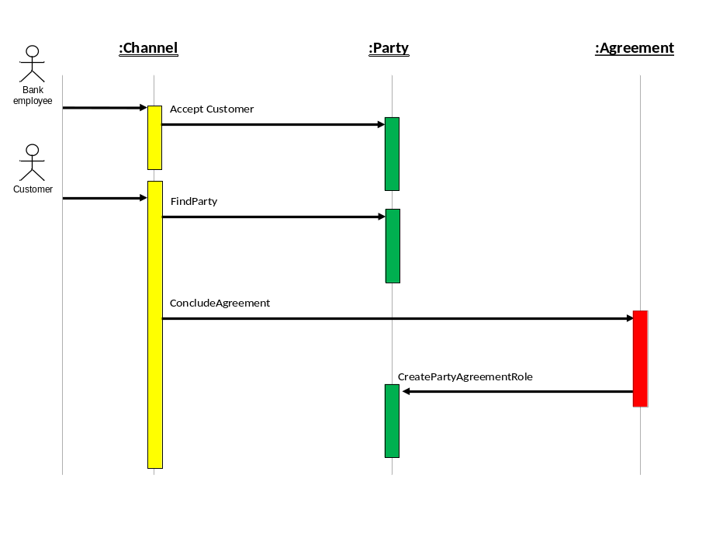
<Data architecture Physical Level View Description: This sub-section may provide a description of the physical level view(s) for the baseline Data architecture in order to understand the architectural decisions that have been taken and resulting key messages for the stakeholders.>

<Data architecture Physical Level Artifact Definitions: This sub-section may provide (in table format) definitions for the physical data entities in scope for the baseline Data architecture.>

<Example: Is this interaction caused by the fact that the other owns the object that has caused the interaction? Is the ownership defined correctly? If we changed ownership of one of the elements, would that lead to a better result?
Often models like shown below are used for this View>

Baseline Data Architecture Cross References
<Data Architecture Cross References: This section provides, if necessary or when available, some cross references for the data architecture.>

Application Architecture Models

<The purpose of this Baseline Application Architecture sub-section is to define the baseline application architecture for the domain/sub-domain.
Mandatory/optional: If this document is to be produced, this sub-section is mandatory. However, the domain only needs to produce the relevant artifacts from those highlighted in this section as per their needs.
In terms of quality criteria, this section may make clear:
- Relevant views (diagrams) at the conceptual level illustrating the application services and their contracts (interactions) in scope for the baseline application architecture;
- Description of the conceptual level view(s) in order to understand the architectural decisions that have been taken and resulting key messages for the stakeholders;
- Definitions for the application services (in table format) in scope for the baseline application architecture;
- Characteristics of the application services (in table format) in scope for the baseline application architecture. The domains will need to decide whether characteristics are needed at the conceptual services level, logical component level, or both levels;
- Descriptions of the contracts (interactions) between the application services (in table format) in scope for the baseline application architecture;
- If required, characteristics of the contracts (interactions) between the application services (in table format) in scope for the baseline application architecture;
- Relevant views (diagrams) at the logical level illustrating the logical application components and their contracts (interactions) in scope for the baseline application architecture. These logical application components group application services together based on common requirements/characteristics;
- Description of the logical level view(s) in order to understand the architectural decisions that have been taken and resulting key messages for the stakeholders;
- Definitions for the logical application components (in table format) in scope for the baseline Information architecture;
- Characteristics of the logical application components (in table format) in scope for the baseline application architecture. The domains will need to decide whether characteristics are needed at the conceptual services level, logical component level, or both levels;
- Descriptions of the contracts (interactions) between the logical application components (in table format) in scope for the baseline application architecture;
- Characteristics of the contracts (interactions) between the logical application components (in table format) in scope for the baseline application architecture;
- Any relationships between the business function categories, business functions, logical application components, and application services that are in scope for the baseline architecture;
- Any relationships between the business services and application services that are in scope for the baseline architecture;
- Any additional viewpoints and thus views that are required for this section due to new stakeholder requirements. These views will then be followed by descriptions for the views and definitions for the view artifacts;
- Any assumptions that have been used to define the baseline application architecture. For example, one assumption (recommendation) that has already been stated is that the physical application architecture is out of scope for the xxxx Enterprise Architecture.>

Conceptual Baseline Application Architecture

<Application Architecture Conceptual Level Example: This sub-section may provide one or more conceptual level views for the baseline application architecture. The diagram below provides an example view of the baseline application architecture at the conceptual level which consists of application services. This particular example illustrates some of the application services, grouped by domain, within xxxx. However, the definition of application services can only be confirmed during the architectural analysis for each domain. Text describing the key concepts and notation used within the diagram will also need to be included so that users can easily read and understand the view.>

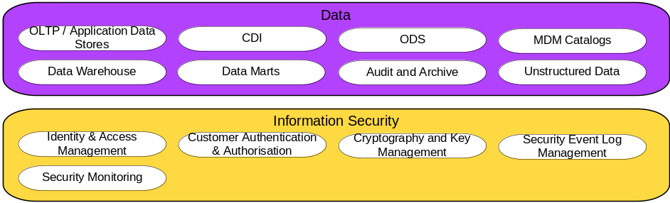

<Application Architecture Conceptual Level View Description: This sub-section may provide a description of the conceptual level view(s) for the baseline application architecture in order to understand the architectural decisions that have been taken and resulting key messages for the stakeholders.>

Baseline Application Services

<Application Architecture Conceptual Level Artifact Definitions: This sub-section may provide (in table format) definitions for the application services in scope for the baseline application architecture.>

Application Service  Id | Application Service | Application Service Description

<Application Architecture Conceptual Level Artifact Characteristics: This sub-section may need to provide (in table format) characteristics for the application services in scope for the baseline application architecture. However, the domain will need to decide whether characteristics are needed at the conceptual services level, logical component level, or both levels. The domain also needs to determine which characteristics they wish to capture..>

Application Service | Application Service Characteristic | Application Service Characteristic Value

Application Services Contracts

<Application Architecture Conceptual Service Contracts: This sub-section provides (in table format) the contracts between Application Services and the characteristics of those contracts for the application services in scope for the baseline application architecture. However, the domain will need to decide whether characteristics are needed at the conceptual services level, logical component level, or both levels. The domain also needs to determine which characteristics they wish to capture.>

Contract Name | Contract ID | Definition | IS Service 1 | IS Service 2

User Satisfaction
<Application Architecture Services User Satisfaction: This sub-section provides a view of current user satisfaction rates for the subject areas. It contains detailed information about complaints and positive features of the current subject areas.>

Application Services | User Satisfaction (Scale 1-10) | Notes, Specific Issues

Application Service Security Classification View
< Application Service Security Classification View Example: This sub-section may provide one or more views of security classification for the baseline application services.>

< Application Service Security Classification View Description: application Services have attributes that can describe various functional and non-functional aspects. Among these attributes is the security classification.
Project architecture documents must take the security classifications of the artefacts that will be impacted by the project and ensure both that the intended solution is using appropriately secure artefacts and that it will not have a negative impact on the security of those artefacts. >
Reference-id* com-ponent | Title* component | Reference-id* | Title* | Subject | Confidentiality Classification | Integrity Classification | Availability Classification

Logical Baseline Application Architecture

<Application Architecture Logical Level Example: This sub-section may provide one or more logical level views for the baseline application architecture. The diagram below provides a view of the baseline application architecture at the logical level which consists of logical application components (although without their associated application services). However, the definition of logical application components can only be confirmed during the architectural analysis for each domain. Text describing the key concepts and notation used within the diagram will also need to be included so that users can easily read and understand the view.>

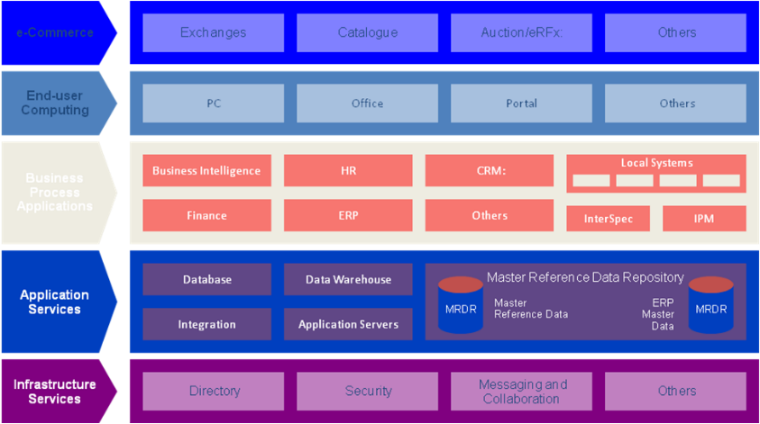

<Application Architecture Logical Level View Description: This sub-section may provide a description of the logical level view(s) for the baseline application architecture in order to understand the architectural decisions that have been taken and resulting key messages for the stakeholders.>

<Application Architecture Logical Level Artifact Definitions: This sub-section may provide (in table format) definitions for the logical application components in scope for the baseline application architecture.>

LAC Id | Logical Application Component (LIC) | Logical Application Component (LIC) Description

<Application Architecture Logical Level Artifact Characteristics: This sub-section may need to provide (in table format) characteristics for the logical application components in scope for the baseline application architecture. However, the domain will need to decide whether characteristics are needed at the conceptual services level, logical component level, or both levels. The domain also needs to determine which characteristics they wish to capture.>

Logical Application Component (LAC) | LAC Characteristic | LAC Characteristic Value

<Application Architecture Logical Level Artifact Contracts: This sub-section may provide (in table format) descriptions of the contracts (i.e. interactions/relationships) between the logical application components in scope for the baseline application architecture.>

LAC Contract Id | LAC Contract | Logical Application  Component 1 | Logical Application Component 2 | LAC Contract Description

<Application Architecture Logical Level Artifact Contract Characteristics: This sub-section may provide (in table format) characteristics of the contracts (i.e. interactions/relationships) between the logical application components in scope for the baseline application architecture. The domain needs to determine which characteristics they wish to capture.>

LAC Contract | LAC Contract Characteristic | LAC Contract Characteristic Value

Physical Baseline Application Architecture
<Application Architecture Physical Applications Catalogue: This sub-section provides a catalogue of the currently used applications.>

PAC Id | Physical Application Component (PAC) | Physical Application Component (PAC) Description | Implementation Features | Technical Fitness Score (1-10) | Business Fitness Score (1-10) | Business Importance (1-10)

Baseline Application Architecture Cross References

<Application Architecture Cross References: This section provides, if necessary or when available, some cross references for the application architecture. Like Application Service and Infrastructure Service Cross References or Business Service and Application Service Cross References. See the Target template for descriptions of those.>

Technology Architecture Models
<The purpose of this Baseline Technology Architecture sub-section is to provide a high-level view of the baseline technology architecture for the domain.
Mandatory/optional: This sub-section is optional. If produced, the domain only needs to produce the relevant artifacts from those highlighted in this sub-section as per their needs.
In terms of quality criteria, this section may make clear:
- Relevant views (diagrams) at the conceptual level illustrating the infrastructure services and their contracts (interactions) in scope for the baseline technology architecture;
- Description of the conceptual level view(s) in order to understand the architectural decisions that have been taken and resulting key messages for the stakeholders;
- Definitions for the infrastructure services (in table format) in scope for the baseline technology architecture;
- Characteristics of the infrastructure services (in table format) in scope for the baseline technology architecture. The domains will need to decide whether characteristics are needed at the conceptual services level, logical component level, or both levels;
- Descriptions of the contracts (interactions) between the infrastructure services (in table format) in scope for the baseline technology architecture;
- If required, characteristics of the contracts (interactions) between the infrastructure services (in table format) in scope for the baseline technology architecture;
- Relevant views (diagrams) at the logical level illustrating the logical infrastructure components and their contracts (interactions) in scope for the baseline technology architecture. These logical infrastructure components group infrastructure services together based on common requirements/characteristics;
- Description of the logical level view(s) in order to understand the architectural decisions that have been taken and resulting key messages for the stakeholders;
- Definitions for the logical infrastructure components (in table format) in scope for the baseline technology architecture;
- Characteristics of the logical infrastructure components (in table format) in scope for the baseline technology architecture. The domains will need to decide whether characteristics are needed at the conceptual services level, logical component level, or both levels;
- Descriptions of the contracts (interactions) between the logical infrastructure components (in table format) in scope for the baseline technology architecture;
- Characteristics of the contracts (interactions) between the logical infrastructure components (in table format) in scope for the baseline technology architecture;
- Any relationships between the business function categories, business functions, logical infrastructure components, and infrastructure services that are in scope for the baseline architecture;
- Any relationships between the business services and infrastructure services that are in scope for the baseline architecture;
- Any additional viewpoints and thus views that are required for this section due to new stakeholder requirements. These views will then be followed by descriptions for the views and definitions for the view artifacts;
- Any assumptions that have been used to define the baseline technology architecture. For example, one assumption (recommendation) that has already been stated is that the physical technology architecture is out of scope for the Enterprise Architecture.>

Conceptual Baseline Technology Architecture
<Technology architecture Conceptual Level Example: This sub-section may provide one or more conceptual level views for the baseline technology architecture. The diagram below provides a view of the baseline technology architecture at the conceptual level which consists of infrastructure services. This particular example illustrates some of the infrastructure services within xxxxx. However, the definition of infrastructure services can only be confirmed during the architectural analysis for each domain. Text describing the key concepts and notation used within the diagram will also need to be included so that users can easily read and understand the view.>

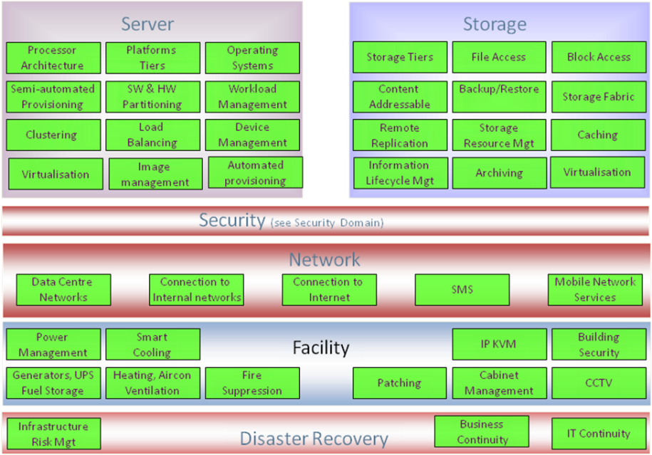

<Technology architecture Conceptual Level View Description: This sub-section may provide a description of the conceptual level view(s) for the baseline technology architecture in order to understand the architectural decisions that have been taken and resulting key messages for the stakeholders.>

Technology Services

<Technology architecture Conceptual Level Artifact Definitions: This sub-section may provide (in table format) definitions for the infrastructure services in scope for the baseline technology architecture.>

Infrastructure Service Id | Infrastructure Service | Infrastructure Service Description

<Technology architecture Conceptual Level Artifact Characteristics: This sub-section may need to provide (in table format) characteristics for the infrastructure services in scope for the baseline technology architecture. However, the domain will need to decide whether characteristics are needed at the conceptual services level, logical component level, or both levels. The domain also needs to determine which characteristics they wish to capture.>

Infrastructure Service | Infrastructure Service Characteristic | Infrastructure Service Characteristic Value

Technology Services Contracts

<Technology Architecture Conceptual Service Contracts: This sub-section provides (in table format) the contracts between Infrastructure Services and the characteristics of those contracts for the infrastructure services in scope for the baseline technology architecture. However, the domain will need to decide whether characteristics are needed at the conceptual services level, logical component level, or both levels. The domain also needs to determine which characteristics they wish to capture.>

Contract Name | Contract ID | Definition | IS Service 1 | IS Service 2

User Satisfaction
<Technology Architecture Services User Satisfaction: This sub-section provides a view of current user satisfaction rates for the subject areas. It contains detailed information about complaints and positive features of the current subject areas.>

Technology Services | User Satisfaction (Scale 1-10) | Notes, Specific Issues

Logical Baseline Technology Architecture

<Technology architecture Logical Level Example: This sub-section may provide one or more logical level views for the baseline technology architecture. The diagram below provides a view of the baseline technology architecture at the logical level which consists of logical infrastructure components with their associated infrastructure services. This particular example illustrates some of the logical infrastructure components and associated infrastructure services within xxxxxx. However, the definition of logical infrastructure components can only be confirmed during the architectural analysis for each domain. Text describing the key concepts and notation used within the diagram will also need to be included so that users can easily read and understand the view.>

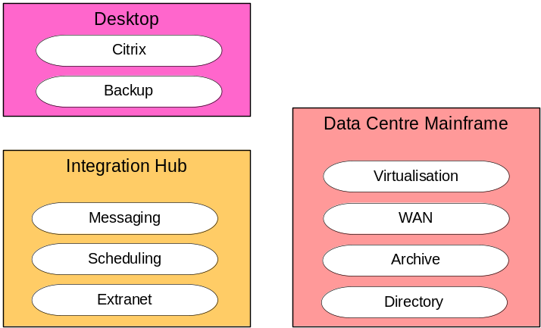

<Technology architecture Logical Level View Description: This sub-section may provide a description of the logical level view(s) for the baseline technology architecture in order to understand the architectural decisions that have been taken and resulting key messages for the stakeholders.>

<Technology architecture Logical Level Artifact Definitions: This sub-section may provide (in table format) definitions for the logical infrastructure components in scope for the baseline technology architecture.>

LIC Id | Logical Infrastructure Component (LIC) | Logical Infrastructure Component (LIC) Description

<Technology architecture Logical Level Artifact Characteristics: This sub-section may provide (in table format) characteristics for the logical infrastructure components in scope for the baseline technology architecture.>

Logical Infrastructure Component (LIC) | LIC Characteristic | LIC Characteristic Value

<Technology architecture Logical Level Artifact Contracts: This sub-section may provide (in table format) descriptions of the contracts (i.e. interactions/relationships) between the logical infrastructure components in scope for the baseline technology architecture.>

LIC Contract Id | Logical Infrastructure Component 1 | Logical Infrastructure Component 2 | LIC Contract Description

<Technology architecture Logical Level Artifact Contract Characteristics: This sub-section may provide (in table format) characteristics of the contracts (i.e. interactions/relationships) between the logical infrastructure components in scope for the baseline technology architecture.>

Logical Infrastructure Component (LIC) | LIC Contract | LIC Contract Characteristic | LIC Contract Characteristic Value

Physical Baseline Technology Architecture

<Technology Architecture Physical Infrastructure Component Catalogue: This sub-section provides a catalogue of the currently used applications.>

PIC Id | Physical Infrastructure Component (PIC) | Physical Infrastructure Component (PIC) Description | Implementation Features | Technical Fitness Score (1-10) | Business Fitness Score (1-10) | Business Importance (1-10)

Baseline Technology Architecture Cross References
<Technology Architecture Cross References: This section provides, if necessary or when available, some cross references for the technology architecture. See the Target template for descriptions of those.>

Security Architecture Models

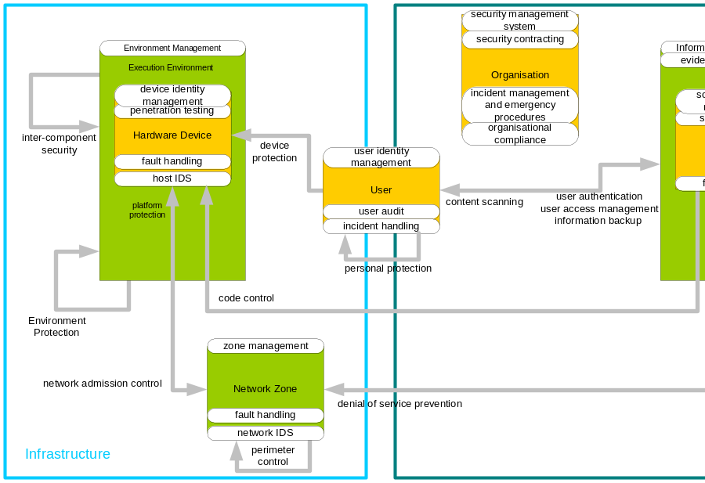

Service Name | Description | Type | Baseline Specification: Policy Reference

Rationale and Justification for Architectural Approach

Rationale

Approach

Architecture Decisions

ID | Decision Item | Decision Made | Completion Date | Source | Owner / Major Contributors

Architecture Governance

Mapping to Architecture Repository
<The purpose of this section is to highlight (not describe in detail) patterns, standards, products, technologies that are relevant for or from the business architecture.
Mandatory/optional: This section is mandatory. Also, each of the sub-sections (for this section) may either provide references to the relevant documentation that has been produced separately by the domains, or provide the necessary information.
In terms of quality criteria, this section should make clear:
- Any domain specific, other domain specific, or Enterprise Architecture level patterns that have been used to help define the business architecture;
- Any domain specific, other domain specific, or Enterprise Architecture level patterns that can be derived from the business architecture;
- Any deviance from existing patterns and the reasons why;
- Any domain specific, other domain specific, or Enterprise Architecture level standards that have been used to help define the business architecture;
- Any domain specific, other domain specific, or Enterprise Architecture level standards that can be derived from the business architecture;
- Any deviance from existing standards and the reasons why;
- Any assumptions regarding the use of patterns or standards.
>

Artefacts
<The purpose of this section is to describe the artefacts that are relevant for or from the business architecture.
Mandatory/optional: This sub-section is optional as there may not be any used artefacts. However, if they are relevant, this sub-section may either provide references to the relevant documentation that has been produced separately by the domains, or provide the necessary information.
If the relevant artifact(s) are described in other documentation, in terms of quality criteria, this sub-section should make clear:
- The relevant business architecture artefact documentation;
- Context around any such relevant business architecture artefact documentation e.g. validity, ownership, purpose;
- Any deviance from existing business artefacts and the reasons why;
- Any assumptions regarding business architecture artefacts, or their documentation.

If the relevant business pattern(s) are not described in other documentation, in terms of quality criteria, this sub-section should make clear:
- Any domain specific, other domain specific, or xxxxx Enterprise Architecture level artefacts that have been used to help define the business architecture;
- Any domain specific, other domain specific, or xxxxx Enterprise Architecture level artefacts that can be derived from the business architecture;
- Any deviance from existing business artefacts and the reasons why;
- Any assumptions regarding business architecture artefacts, or their documentation.>

Mapping to Architecture Landscape
<The purpose of this sub-section is to highlight any business patterns that are relevant for or from the business architecture.
Mandatory/optional: This sub-section is optional as there may not be any relevant business patterns. However, if they are relevant, this sub-section may either provide references to the relevant documentation that has been produced separately by the domains, or provide the necessary information.
If the relevant business pattern(s) are described in other documentation, in terms of quality criteria, this sub-section should make clear:
- The relevant business architecture pattern documentation;
- Context around any such relevant business architecture pattern documentation e.g. validity, ownership, purpose;
- Any deviance from existing business patterns and the reasons why;
- Any assumptions regarding business architecture patterns, or their documentation.

If the relevant business pattern(s) are not described in other documentation, in terms of quality criteria, this sub-section should make clear:
- Any domain specific, other domain specific, or xxxxxx Enterprise Architecture level patterns that have been used to help define the business architecture;
- Any domain specific, other domain specific, or xxxxx Enterprise Architecture level patterns that can be derived from the business architecture;
- Any deviance from existing business patterns and the reasons why;
- Any assumptions regarding business architecture patterns, or their documentation.>

Mapping to Reference Models
<The purpose of this sub-section is to highlight any products and technologies that are relevant to the baseline architecture.
Mandatory/optional: This sub-section is optional as there may not be any relevant products and technologies. However, if they are relevant, this sub-section may either provide references to the relevant documentation that has been produced separately by the domains, or provide the necessary information.
If the relevant product(s) and technology(s) are described in other documentation, in terms of quality criteria, this sub-section should make clear:
- The relevant products and technologies documentation;
- Context around any such relevant products and technologies documentation e.g. validity, ownership, purpose;
- Any deviance from existing products and technologies and the reasons why;
- Any assumptions regarding the products and technologies, or their documentation.

If the relevant product(s) and technology(s) are not described in other documentation, in terms of quality criteria, this sub-section should make clear:
- Any domain specific, other domain specific, or xxxx Enterprise Architecture level products and technologies that have been used to help define the current architecture;
- Any deviance from existing products and technologies and the reasons why;
- Any assumptions regarding the products and technologies, or their documentation.>

Mapping to Standards
<The purpose of this sub-section is to highlight any business standards that are relevant for or from the business architecture.
Mandatory/optional: This sub-section is optional as there may not be any relevant business standards. However, if they are relevant, this sub-section may either provide references to the relevant documentation that has been produced separately by the domains, or provide the necessary information.
If the relevant business standards(s) are described in other documentation, in terms of quality criteria, this sub-section should make clear:
- The relevant business architecture standards documentation;
- Context around any such relevant business architecture standards documentation e.g. validity, ownership, purpose;
- Any deviance from existing business standards and the reasons why;
- Any assumptions regarding the business architecture standards, or their documentation.

If the relevant business standards(s) are not described in other documentation, in terms of quality criteria, this sub-section should make clear:
- Any domain specific, other domain specific, or xxxxx Enterprise Architecture level standards that have been used to help define the business architecture;
- Any domain specific, other domain specific, or xxxxx Enterprise Architecture level standards that can be derived from the business architecture;
- Any deviance from existing business standards and the reasons why;
- Any assumptions regarding the business architecture standards, or their documentation.>

Re-Use Assessment
<The purpose of this sub-section is to highlight any reusable aspects of the business architecture.
Mandatory/optional: This sub-section is optional as there may not be any reusable aspects of the business architecture.
If there are reusable aspects, in terms of quality criteria, this sub-section should make clear:
- Drivers for reuse in different business areas;
- Any reusable artifacts that have been used to help define the business architecture;
- Any reusable artifacts that can be derived from the business architecture;
- Extensions to existing artifacts in order to make them reusable;
- Any non-usage of reusable artifacts and the reasons why;
- Deployment options for reuse which an indication of priorities;
- Any assumptions regarding reusability.>

Use of existing components
< Brief summary of how the solution architecture proposes to re-use existing components (if any). Include re-use of licences, infrastructure, support services (e.g. DR) as well as software components.>

Opportunities for re-use
<Summarise those components that have been designed for re-use.>

Target Architecture

Business Architecture Models
<The purpose of this Target Business Architecture section is to define the target business architecture that is in scope for this exercise.

Note: This section may be refined once the business architecture team has been set up.

Note 2: The level of granularity at which the artefacts need to be defined is dependant on the level of detail that is required from the business architecture, and thus is a decision for the individual domains.

Mandatory/optional: This section is optional as the domain may only wish to produce a current business architecture. Also, a degree of flexibility exists when documenting each of the sub-sections within this section. The domain only needs to produce the relevant artifacts from those highlighted in this section as per their needs. They do not need to produce all the artifacts, views, tables etc. presented in this section.

In terms of quality criteria, this section may make clear:
- Any other relevant business architecture documentation;
- Context around any such relevant business architecture documentation e.g. validity, ownership, purpose;
- Any assumptions regarding the business architecture documentation.
- Relevant views (diagrams) illustrating the business functions in scope for the target business architecture;
- Description of the business function view(s);
- Definitions for the business functions (in table format) in scope for the target business architecture;
- Relevant views (diagrams) illustrating the organisation structure and units in scope for the target business architecture;
- Description of the organisation structure and units view(s);
- Definitions for the organisation structure and units (in table format) in scope for the target business architecture;
- Relevant views (diagrams) at the conceptual level illustrating the conceptual business services and their contracts (interactions) in scope for the target business architecture;
- Description of the conceptual level view(s) in order to understand the architectural decisions that have been taken and resulting key messages for the stakeholders;
- Definitions for the conceptual business services (in table format) in scope for the target business architecture;
- Characteristics of the conceptual business services (in table format) in scope for the target business architecture;
- Descriptions of the contracts (interactions) between the conceptual business services (in table format) in scope for the target business architecture;
- If required, characteristics of the contracts (interactions) between the business services (in table format) in scope for the target business architecture;
- Relevant views (diagrams) at the logical level illustrating the business processes in scope for the target business architecture;
- Description of the logical level view(s) in order to understand the architectural decisions that have been taken and resulting key messages for the stakeholders;
- Definitions for the business processes (in table format) in scope for the target business architecture;
- Any relationships between the business function categories, business functions, business service categories and business services that are in scope for the target business architecture;
- Any assumptions that have been used to define the target business architecture.>

Conceptual Target Business Architecture

Target Business Functions

<Business Architecture Function View Example: This sub-section needs to provide one or more business function views for the target business architecture. The diagram below provides a view of the target business function categories and business functions. This particular example illustrates some of the business function categories and business functions within xxxxx. However, the definition of business function categories and business functions can only be confirmed during the architectural analysis for each domain. Text describing the key concepts and notation used within the diagram will also need to be included so that users can easily read and understand the view.>
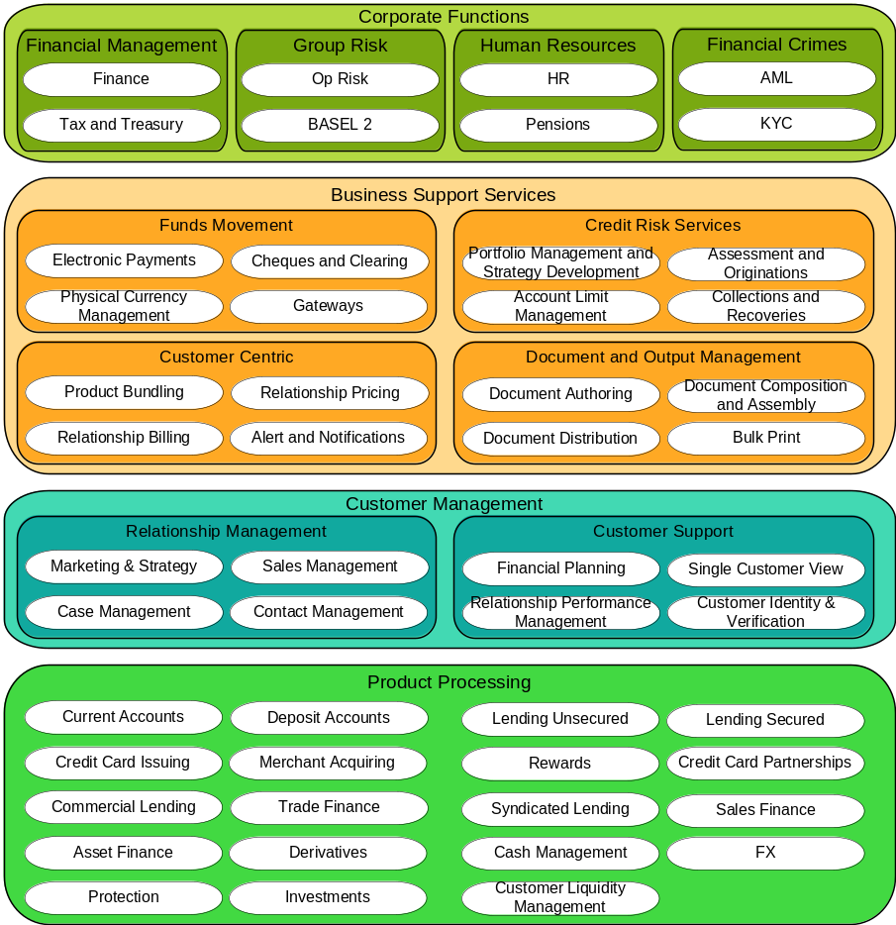
<Business Architecture Function View Description: This sub-section needs to provide a description of the business function view(s) for the target business architecture in order to understand the key messages for the stakeholders.>

<Business Architecture Function Definitions: This sub-section needs to provide (in table format) definitions for the business function categories and business functions in scope for the target business architecture.>

Business Function (Category) Id | Business Function Category | Business Function | Business Function Description

Target Business Services
<Business Architecture Conceptual Level View Example: This sub-section needs to provide one or more conceptual level views for the target business architecture. The diagram below provides a view of the target business architecture at the conceptual level which consists of business service categories and business services. This particular example illustrates some of the business services within XXXX. However, the definition of business services can only be confirmed during the architectural analysis for each domain. Text describing the key concepts and notation used within the diagram will also need to be included so that users can easily read and understand the view.>
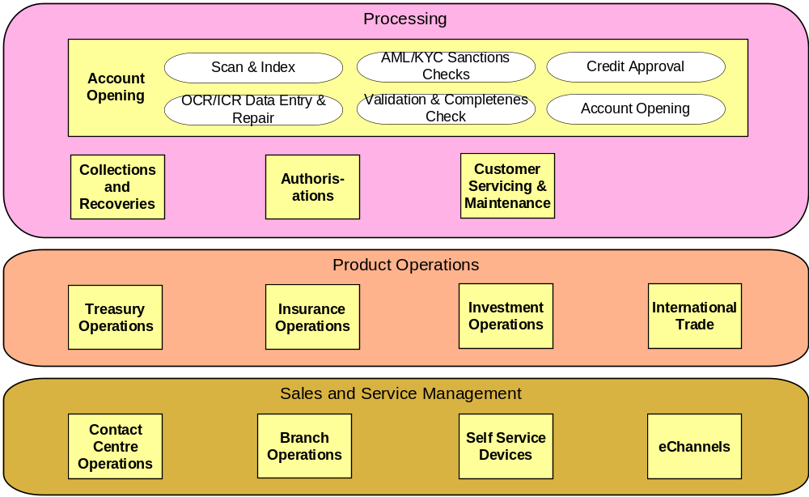

<Business Architecture Conceptual Level View Description: This sub-section needs to provide a description of the conceptual level view(s) for the target business architecture in order to understand the architectural decisions that have been taken and resulting key messages for the stakeholders.>
<Business Architecture Conceptual Level Artifact Definitions: This sub-section needs to provide (in table format) definitions for the business service categories and business services in scope for the target business architecture.

Governance services: The services must cover the complete scope of the architecture, including governance and service management. Additional services can be identified by considering how the main services, when implemented, will be instantiated, started up, shut down, configured, monitored, and how faults will be diagnosed, users maintained, new business configuration items added (e.g. products) and so on. For more technical services, management functions such as provisioning, key management, identity management, backup, recovery, business continuity should be considered.>
Business Service (Category) Id | Business Service Category | Business Service | Business Service Description
<Business services capability mapping: this table provides a mapping between the capabilities and the business services.>
Capability Id | Capability | Business Service
<Business Architecture Conceptual Level Artifact Characteristics: This sub-section may provide (in table format) characteristics for the business services in scope for the target business architecture.>

Business Service | Business Service Characteristic | Business Service Characteristic Value

<Business Architecture Conceptual Level Artifact Contracts: This sub-section may provide (in table format) descriptions of the contracts (i.e. interactions/relationships) between the business services in scope for the target business architecture.>

BS Contract Id | Business Service Contract | Business Service 1 | Business Service 2 | Business Service Contract Description

<Business Architecture Conceptual Level Artifact Contract Characteristics: This sub-section may provide (in table format) characteristics of the contracts (i.e. interactions/relationships) between the business services in scope for the target business architecture. The domain needs to determine which characteristics they wish to capture.>

Business Service Contract | Business Service Contract Characteristic | Business Service Contract Characteristic Value

Business Service Security Classification View

< Business Service Security Classification View Example: This sub-section may provide one or more views of security classification for the target business services.>

< Business Service Security Classification View Description: Business Services have attributes that can describe various functional and non-functional aspects. Among these attributes is the security classification. The context within which a Business Service operates can be derived from the Information Objects, as these objects can have a CIA classification.
The definition of the Business Service security should be carried out before a project is initiated as part of a Business Impact Analysis.
Project architecture documents must take the security classifications of the artefacts that will be impacted by the project and ensure both that the intended solution is using appropriately secure artefacts and that it will not have a negative impact on the security of those artefacts. >
Reference-id* | Title* | Subject | Confidentiality Classification | Integrity Classification | Availability Classification

Organisation Structure and Units

<Target Architecture Organisation View Example: This sub-section may provide one or more views of organisational structure and units for the target business architecture.

< Target Architecture Organisation View Description: This sub-section needs to provide a description of the organisational structure and units view(s) for the target business architecture in order to understand the key messages for the stakeholders.>
< Target Architecture Organisation Definitions: This sub-section needs to provide (in table format) definitions for the organisational structure and units in scope for the target business architecture.>

Organisation Unit Id | Organisation Unit | Organisation Unit Parent | Organisation Unit Description

Org. comp  Business Service | Org. Comp 1 | Org. Comp 2 | Org. Comp 3
BS 1 | X
BS 2
BS 3
BS 4

Roles
<The purpose of this Roles section is to describe the roles in the baseline architecture.
Mandatory/optional: This section is optional.
In terms of quality criteria, this section should make clear:
- Human (system) roles in the baseline architecture;
- Computer (system) roles in the baseline architecture.>

Logical Target Business Architecture

Actors
<The purpose of this Actors section is to describe the system users/actors in scope for the target architecture. System actors/users are those users who interact with a system. They can be human or a system/computer.
Mandatory/optional: This section is optional.
In terms of quality criteria, this section should make clear:
- Human (system) actors in scope for the baseline architecture;
- Computer (system) actors in scope for baseline architecture;
- Any other system actor oriented requirements in scope for the target architecture.>

Human Actors
<The purpose of this Human Actors sub-section is to define the human actors in scope for the target architecture.
Mandatory/optional: This sub-section is optional.
In terms of quality criteria, this sub-section should make clear:
- Human actors in scope for the target architecture.>

Computer Actors
<The purpose of this Computer Actors sub-section is to define the computer actors in scope for target architecture.
Mandatory/optional: This sub-section is optional.

In terms of quality criteria, this sub-section should make clear:
- Computer actors and roles in scope for target architecture.>

Actor  Business role | Actor 1 | Actor 2 | Actor 3
Role 1 | X
Role 2
Role 3
Role 4

Other Requirements
<The purpose of Other Requirements sub-section is to define any other actor oriented requirements in scope for the target architecture.
Mandatory/optional: This sub-section is optional.
In terms of quality criteria, this sub-section should make clear:
- Any other actor oriented requirements in scope for the target architecture.>

Logical Business Top Level View
< Logical Business Top Level View Example: This sub-section may provide one or more top-level logical views for the target business architecture.

< Logical Business Top Level View Description:
Concern What are the highest level structuring principles we have to obey?
Description Defines and shows the highest aggregation level to be used for the business architecture, often the business domains, based on a high level structuring of services delivered to the outside world by the business. Often 1 level more detailed than the context diagram.
Guidance This view helps ensure correct Sponsor communication of the architecture. It demonstrates the products and / or services that the business is delivering to the customers grouped per business domain. This is often 1 level more detailed than the context diagram. >

Target Business Architecture (Processes)

<The purpose of this Process Mapping section is to outline the environment and process models that are in scope for the target architecture.

Mandatory/optional: This section is mandatory.

In terms of quality criteria, this section should make clear:
- Business processes that are in scope for the vision;
- Business and technology environment in scope for the vision;
- Users who interact with the business process;
- Information flows for the business processes.>

Process Outline
<The purpose of this Process Outline sub-section is to outline the business processes that are in scope and thus impacted by the target architecture.

Mandatory/optional: This sub-section is mandatory.

In terms of quality criteria, this sub-section should make clear:
- Business processes that are in scope for the vision;
- If required, high level diagram(s) of business processes;
- Descriptions for the business process diagrams.>

Process Steps Mapped to Environment
<The purpose of this Process Steps Mapped to Environment sub-section is to cross reference the business processes, in scope, to the business and technology environments.

Mandatory/optional: This sub-section is mandatory.

In terms of quality criteria, this sub-section should make clear:
- Business environment in scope for the vision;
- Technology environment in scope for the vision.>

Process comp  Environment | Process Comp 1 | Process Comp 2 | Process Comp 3
Environment 1 | X |  | X
Environment 2 |  | X
Environment 3 |  | X
Environment 4 |  |  | X

Process Steps Mapped to People
<The purpose of this Process Steps Mapped to People sub-section is to cross reference the business processes to business actors i.e. business users. Business actors/users are those users who interact with a business process.

Mandatory/optional: This sub-section is mandatory.

In terms of quality criteria, this sub-section should make clear:
- Business users involved with the business processes in scope.
Process comp  Business Users | Process Comp 1 | Process Comp 2 | Process Comp 3
User 1 | X |  | X
User 2 |  | X
User 3 |  | X
User 4 |  |  | X

>

Information Flows

<The purpose of this Information Flows sub-section is to describe the information flows that correspond to the business processes in scope for the target architecture.

Mandatory/optional: This sub-section is mandatory.

In terms of quality criteria, this sub-section should make clear:
- Information flows for the business processes in scope.>

Business Architecture Process View

<Business Architecture Process View Example: This sub-section may provide one or more logical level views for the target business architecture. These views will illustrate the business processes in the target business architecture. Text describing the key concepts and notation used within the diagram(s) will also need to be included so that users can easily read and understand the view.>

<Business Architecture Process View Description: This sub-section may provide a description of the business process view(s) in scope for the target business architecture in order to understand the key messages for the stakeholders.>

<Business Architecture Process Definitions: This sub-section may provide (in table format) definitions for the business processes in scope for the target business architecture.>

Physical Target Business Architecture

Process Allocation
< Key locations can be represented geographically, functionally or structurally. The choice of representation depends on the key point(s) of the model. A text based template is provided. >

Location  Physical process | Location 1 | Location 2 | Location 3
Process 1 | X
Process 2
Process 3
Process 4

Physical Business Component RACI View
< View that demonstrates the accountability and responsibility of physical business components, containing business services by Business areas or other external Organizational units.
The presented Information can be very sensitive. This scope and circulation of this view must be agreed in advance. >
 | Business Unit  Actors |  |  | 3rd Party  Actors | Implementation  Actors
Activity | Actor 1 | Actor 2 | Actor 3 | Actor 4 | Actor 5 | Actor 6 | Actor 7
Activity 1 | AR | C
Activity 2 | AR | C |  |  | C | C | I
Activity 3 | A | C |  |  | R | I
Activity 4 |  |  |  |  | AR
Activity 5 | R | C | A | I | C
Activity 6 | C | C | I |  | C | AR | I

Role/Actor Allocation
< The assignment of roles and responsibilities to staff is a very sensitive issue. For this reason this View is rarely included within an architecture document, but it is sometimes required as an additional View that will be circulated under a separate cover. Such Views will always require the involvement of the HR department and senior managers and such stakeholders are often the sponsors for the extra document that contains the View. >

Staff type  Physical process | Staff type 1 | Staff type 2 | Staff type 3
Actor / role 1 | X
Actor / role 2
Actor / role 3
Actor / role 4

Physical Organisation Model
< The creation of a physical organisational model is a very sensitive issue. For this reason this View is rarely included within an architecture document, but it is sometimes required as an additional View that will be circulated under a separate cover. Such Views will always require the involvement of the HR department and senior managers and such stakeholders are often the sponsors for the additional documentation.>

Cross References within the Business Architecture
<Business Architecture Cross References Example: This sub-section may populate the spreadsheet below which enables the definitions and relationships between business function categories, business functions, business service categories, business services to be captured and documented.

Business Function & Service Descriptions
Business Function Category | Business Function | Business Service Group | Business Service
<Business Function Category Name> | <Business Function Description>
 | <Business Function Name> | <Business Function Description>
 |  | <Business Service Category Name> | <Business Service Category Description>
 |  |  | <Business Service Name> | <Business Service Description>
 |  |  | <Business Service Name> | <Business Service Description>
 |  |  | <Business Service Name> | <Business Service Description>

Process comp  Business Service | Process Comp 1 | Process Comp 2 | Process Comp 3
BS 1 | X |  | X
BS 2 |  | X
BS 3 |  | X
BS 4 |  |  | X

>

Data Architecture Models
<The purpose of this Target Data Architecture sub-section is to define the target Data architecture for the domain/sub-domain.
Mandatory/optional: This sub-section is mandatory as all the domain teams need to produce a target Data architecture for their respective domains. However, a degree of flexibility exists when documenting the target Data architecture. The data domain team will produce a detailed set of Data architecture documentation at the planning, conceptual and logical levels, whereas the other domain teams will produce views and define Information artifacts at one or more of the stated three levels depending on their requirements. The other domain teams may decide to just copy views and definitions and relationships from the master Data architecture documentation.
In terms of quality criteria, this sub-section should make clear:
- Relevant views (diagrams) at the planning level illustrating the information subject areas in scope for the target Data architecture, as well as the relationships between them;
- Description of the planning level view(s) for the target Data architecture in order to understand the architectural decisions that have been taken and resulting key messages for the stakeholders;
- Definitions for the information subject areas (in table format) in scope for the target Data architecture;
- Descriptions of the relationships and cardinality (if relevant) between the information subject areas (in table format) in scope for the target Data architecture;
- Relevant views (diagrams) at the conceptual level illustrating the business objects in scope for the target Data architecture, as well as the relationships between them. These medium-level business objects will have been derived from the high-level information subject areas;
- Description of the conceptual level view(s) for the target Data architecture in order to understand the architectural decisions that have been taken and resulting key messages for the stakeholders;
- Definitions for the business objects (in table format) in scope for the target Data architecture;
- Descriptions of the relationships and cardinality (if relevant) between the business objects (in table format) in scope for the target Data architecture;
- Relevant views (diagrams) at the logical level illustrating the logical data entities in scope for the target Data architecture, as well as the relationships between them. These lower-level logical data entities will have been derived from the medium-level business objects;
- Description of the logical level view(s) for the target Data architecture in order to understand the architectural decisions that have been taken and resulting key messages for the stakeholders;
- Definitions for the logical data entities (in table format) in scope for the target Data architecture;
- Characteristics of the logical data entities (in table format) in scope for the target Data architecture;
- Descriptions of the relationships and cardinality (if relevant) between the logical data entities (in table format) in scope for the target Data architecture;
- Any additional viewpoints and thus views that are required for this section due to new stakeholder requirements. These views will then be followed by descriptions for the views and definitions for the view artifacts;
- Any assumptions that have been used to define the target Data architecture. For example, one assumption (recommendation) that has already been stated is that the physical Data architecture is out of scope for the Enterprise Architecture.>

Conceptual Target Data Architecture

<Data Architecture Planning Level View Example: This sub-section needs to provide one or more planning level views for the target Data architecture. The diagram below provides a view of the target Data architecture at the planning level which consists of information subject areas and the relationships between them. The view also shows the decomposition of information subject areas into business objects. This particular example illustrates some of the information subject areas that exist. Text describing the key concepts and notation used within the diagram will also need to be included so that users can easily read and understand the view.>

<Data Architecture Planning Level View Description: This sub-section needs to provide a description of the planning level view(s) for the target Data architecture in order to understand the architectural decisions that have been taken and resulting key messages for the stakeholders.>

<Data Architecture Planning Level Artifact Definitions: This sub-section needs to provide (in table format) definitions for the information subject areas in scope for the target Data architecture.

Governance subject areas: The subject areas must cover the complete scope of the architecture, including governance and service management. Additional areas can be identified by considering how the main areas, when implemented, will be instantiated, started up, shut down, configured, monitored, and how faults will be diagnosed, users maintained, new business configuration items added (e.g. products) and so on.>

Information Subject Area Id | Information Subject Area | Information Subject Area Description

<Data Architecture Planning Level Artifact Relationships: This sub-section needs to provide (in table format) definitions and cardinality for the relationships between the information subject areas in scope for the target Data architecture.>

ISA Relationship Id | Information Subject Area 1 | Information Subject Area 2 | Information Subject Area Cardinality | Information Subject Area Relationship Description

<Data Architecture Conceptual Level View Example: This sub-section needs to provide one or more conceptual level views for the target Data architecture. The diagram below provides a view of the target Data architecture at the conceptual level which consists of business objects and the relationships between them. This particular example illustrates the business objects within the Marketing information subject area. Text describing the key concepts and notation used within the diagram will also need to be included so that users can easily read and understand the view.>

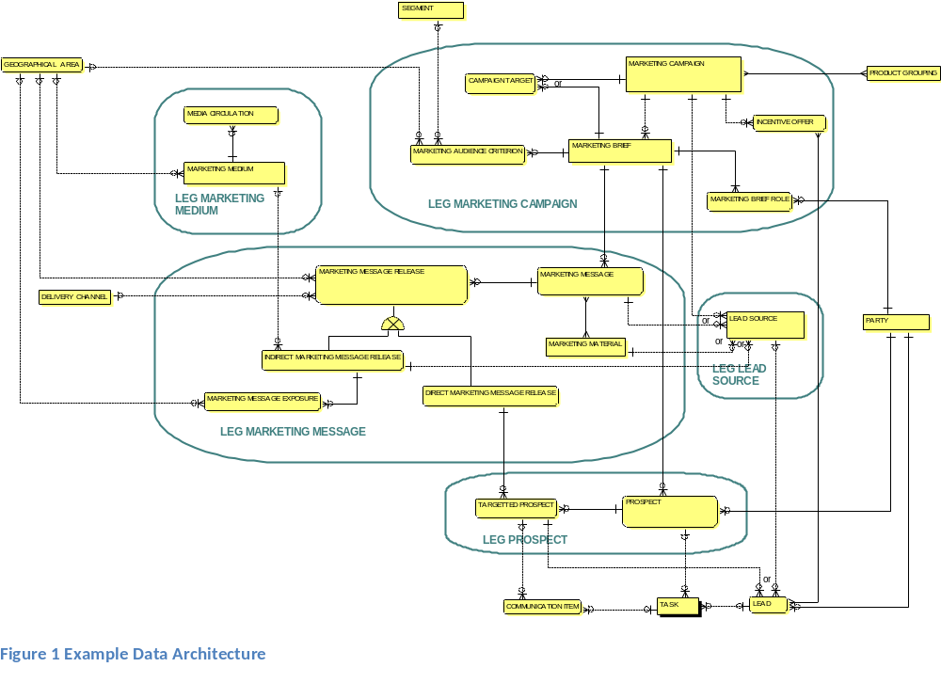

<Data Architecture Conceptual Level View Description: This sub-section needs to provide a description of the conceptual level view(s) for the target Data architecture in order to understand the architectural decisions that have been taken and resulting key messages for the stakeholders.>

<Data Architecture Conceptual Level Artifact Definitions: This sub-section needs to provide (in table format) definitions for the business objects in scope for the target Data architecture. An optional attribute is information classification. With this attribute it is possible to classify the business objects.>

Business Object Id | Business Object | Business Object Description

<Data Architecture Conceptual Level Artifact Relationships: This sub-section needs to provide (in table format) definitions and cardinality for the relationships between the business objects in scope for the target Data architecture.>

BO Relationship Id | Business Object 1 | Business Object 2 | Business Object Cardinality | Business Object Relationship Description

Data Service Security Classification View
< Data Service Security Classification View Example: This sub-section may provide one or more views of security classification for the target data services.>

< Data Service Security Classification View Description: Data Services have attributes that can describe various functional and non-functional aspects. Among these attributes is the security classification. The context within which a Data Service operates can be derived from the Information Objects, as these objects can have a classification.
The definition of the Data Service security should be carried out before a project is initiated as part of a Data Impact Analysis.
Project architecture documents must take the security classifications of the artefacts that will be impacted by the project and ensure both that the intended solution is using appropriately secure artefacts and that it will not have a negative impact on the security of those artefacts. >
Reference-id* com-ponent | Title* component | Reference-id* | Title* | Subject | Confidentiality Classification | Integrity Classification | Availability Classification

Logical Target Data Architecture

<Data Architecture Logical Level View Example: This sub-section needs to provide one or more logical level views for the target Data architecture. The diagram below provides a view of the target Data architecture at the logical level which consists of logical data entities and the relationships between them. This particular example illustrates the logical data entities derived from the Customer business object. Text describing the key concepts and notation used within the diagram will also need to be included so that users can easily read and understand the view.>
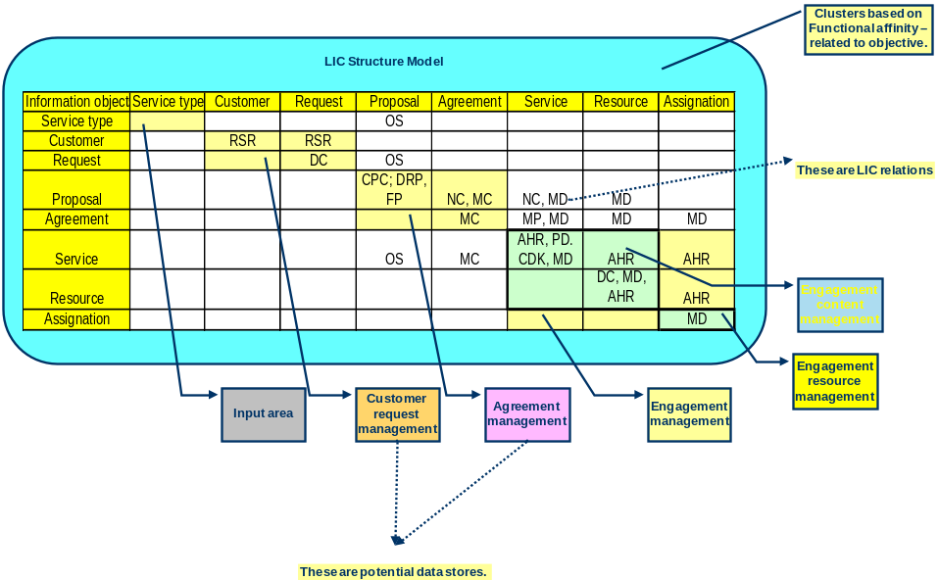

<Data Architecture Logical Level View Description: This sub-section needs to provide a description of the logical level view(s) for the target Data architecture in order to understand the architectural decisions that have been taken and resulting key messages for the stakeholders.>

<Data Architecture Logical Level Artifact Definitions: This sub-section needs to provide (in table format) definitions for the logical data entities in scope for the target Data architecture.>

Logical Data Entity Id | Logical Data Entity | Logical Data Entity Description

<Data Architecture Logical Level Artifact Characteristics: This sub-section needs to provide (in table format) characteristics for the logical data entities in scope for the target Data architecture. The domain needs to determine which characteristics they wish to capture.>

Logical Data Entity | Logical Data Entity Characteristic | Logical Data Entity Characteristic Value

<Data Architecture Logical Level Artifact Attribute Definitions: This sub-section needs to provide (in table format) definitions for the attributes of the logical data entities in scope for the target Data architecture. A separate table may be produced per logical data entity. An optional attribute is information classification. With this attribute it is possible to classify the Logical Data Entities.>

Logical Data Entity | Logical Data Entity Attribute | Logical Data Entity Attribute Description

<Data Architecture Logical Level Artifact Relationships: This sub-section needs to provide (in table format) definitions and cardinality for the relationships between the logical data entities in scope for the target Data architecture.>

LDE Relationship Id | Logical Data Entity 1 | Logical Data Entity 2 | Logical Data Entity Cardinality | Logical Data Entity Relationship Description

Physical Target Data Architecture

< This section describes the interaction between data models that cross ownership boundaries.>

<Data architecture Physical Level View Example: This sub-section may provide one or more logical level views for the target Data architecture. The diagram below provides an example view of the target Data architecture at the physical level which consists of physical data entities and the relationships between them. This particular example illustrates the physical instance of a logical data entities derived from the Customer business object. Text describing the key concepts and notation used within the diagram will also need to be included so that users can easily read and understand the view.
Determine the interaction between the data entities, select and visualize the interactions that cross logical ownership boundaries. Determine the impact of information ownership on these interactions.
>
<Data architecture Physical Level View Description: This sub-section may provide a description of the physical level view(s) for the target Data architecture in order to understand the architectural decisions that have been taken and resulting key messages for the stakeholders.>

<Data architecture Physical Level Artifact Definitions: This sub-section may provide (in table format) definitions for the physical data entities in scope for the target Data architecture.>

<Example: Is this interaction caused by the fact that the other owns the object that has caused the interaction? Is the ownership defined correctly? If we changed ownership of one of the elements, would that lead to a better result?
Often models like shown below are used for this View>

Target Data Architecture Cross Reference

<Data Architecture Cross References: This section provides, if necessary some cross references for the data architecture.>

Application Architecture Models
<The purpose of this Target Application Architecture sub-section is to define the target application architecture for the domain/sub-domain.
Mandatory/optional: This section is mandatory as all the domain teams (excluding the data and infrastructure domains) need to produce a target application architecture at the conceptual and logical levels for their respective domains.
In terms of quality criteria, this section should make clear:
- Relevant views (diagrams) at the conceptual level illustrating the application services and their contracts (interactions) in scope for the target application architecture;
- Description of the conceptual level view(s) in order to understand the architectural decisions that have been taken and resulting key messages for the stakeholders;
- Definitions for the application services (in table format) in scope for the target application architecture;
- Characteristics of the application services (in table format) in scope for the target application architecture. The domains will need to decide whether characteristics are needed at the conceptual services level, logical component level, or both levels;
- Descriptions of the contracts (interactions) between the application services (in table format) in scope for the target application architecture;
- If required, characteristics of the contracts (interactions) between the application services (in table format) in scope for the target application architecture;
- Relevant views (diagrams) at the logical level illustrating the logical application components and their contracts (interactions) in scope for the target application architecture. These logical application components group application services together based on common requirements/characteristics;
- Description of the logical level view(s) in order to understand the architectural decisions that have been taken and resulting key messages for the stakeholders;
- Definitions for the logical application components (in table format) in scope for the target Information architecture;
- Characteristics of the logical application components (in table format) in scope for the target application architecture. The domains will need to decide whether characteristics are needed at the conceptual services level, logical component level, or both levels;
- Descriptions of the contracts (interactions) between the logical application components (in table format) in scope for the target application architecture;
- Characteristics of the contracts (interactions) between the logical application components (in table format) in scope for the target application architecture;
- Any relationships between the business function categories, business functions, logical application components, and application services that are in scope for the target architecture;
- Any relationships between the business services and application services that are in scope for the target architecture;
- Any additional viewpoints and thus views that are required for this section due to new stakeholder requirements. These views will then be followed by descriptions for the views and definitions for the view artifacts;
- Any assumptions that have been used to define the target application architecture. For example, one assumption (recommendation) that has already been stated is that the physical application architecture is out of scope for the Enterprise Architecture.>

Conceptual Target Application Architecture
<Application Architecture Conceptual Level Example: This sub-section needs to provide one or more conceptual level views for the target application architecture. The diagram below provides a view of the target application architecture at the conceptual level which consists of application services. This particular example illustrates some of the possible application services, grouped by domain. However, the definition of application services can only be confirmed during the architectural analysis for each domain. Text describing the key concepts and notation used within the diagram will also need to be included so that users can easily read and understand the view.>

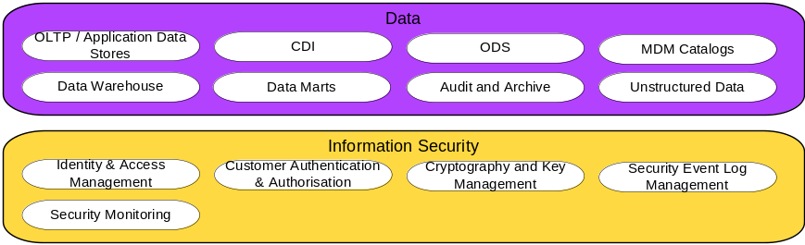

<Application Architecture Conceptual Level View Description: This sub-section needs to provide a description of the conceptual level view(s) for the target application architecture in order to understand the architectural decisions that have been taken and resulting key messages for the stakeholders.>

<Application Architecture Conceptual Level Artifact Definitions: This sub-section needs to provide (in table format) definitions for the application services in scope for the target application architecture.

Governance services: The services must cover the complete scope of the architecture, including governance and service management. Additional services can be identified by considering how the main services, when implemented, will be instantiated, started up, shut down, configured, monitored, and how faults will be diagnosed, users maintained, new business configuration items added (e.g. products) and so on. For more technical services, management functions such as provisioning, key management, identity management, backup, recovery, business continuity should be considered.>

Application Service Id | Application Service | Application Service Description

<Application services capability mapping: this table provides a mapping between the capabilities and the business services.>

Capability Id | Capability | Business Service | Application Service

<Application Architecture Conceptual Level Artifact Characteristics: This sub-section may need to provide (in table format) characteristics for the application services in scope for the target application architecture. However, the domain will need to decide whether characteristics are needed at the conceptual services level, logical component level, or both levels. The domain also needs to determine which characteristics they wish to capture. They may wish to include additional characteristics. Governance and Service Management characteristics should be included here.>

Application Service | Application Service Characteristic | Application Service Characteristic Value

<Application Architecture Conceptual Level Artifact Contracts: This sub-section may provide (in table format) descriptions of the contracts (i.e. interactions/relationships) between the services in scope for the target application architecture.>

CAS Contract Id | CAS Contract | Logical Application  Service 1 | Logical Application Service 2 | CAS Contract Description

<Application Architecture Conceptual Level Artifact Contract Characteristics: This sub-section may provide (in table format) characteristics of the contracts (i.e. interactions/relationships) between the application services in scope for the target application architecture. The domain needs to determine which characteristics they wish to capture.>

CAS Contract | CAS Contract Characteristic | CAS Contract Characteristic Value

Application Service Security Classification View
< Application Service Security Classification View Example: This sub-section may provide one or more views of security classification for the target application services.>

< Application Service Security Classification View Description: application Services have attributes that can describe various functional and non-functional aspects. Among these attributes is the security classification.
Project architecture documents must take the security classifications of the artefacts that will be impacted by the project and ensure both that the intended solution is using appropriately secure artefacts and that it will not have a negative impact on the security of those artefacts. >
Reference-id* com-ponent | Title* component | Reference-id* | Title* | Subject | Confidentiality Classification | Integrity Classification | Availability Classification

Logical Target Application Architecture

<Application Architecture Logical Level Example: This sub-section needs to provide one or more logical level views for the target application architecture. The diagram below provides a view of the target application architecture at the logical level which consists of logical application components with their associated application services. This particular example illustrates some of the possible logical application components and associated application services. However, the definition of logical application components can only be confirmed during the architectural analysis for each domain. Text describing the key concepts and notation used within the diagram will also need to be included so that users can easily read and understand the view.>
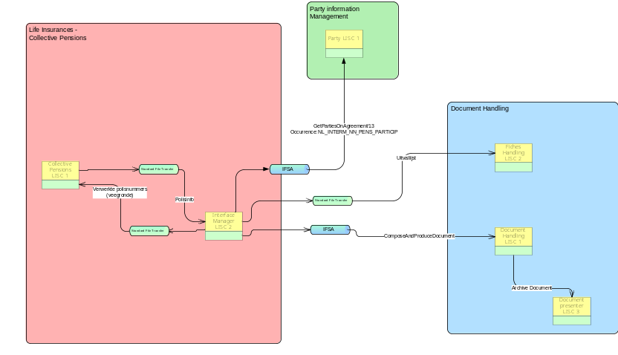

<Application Architecture Logical Level View Description: This sub-section needs to provide a description of the logical level view(s) for the target application architecture in order to understand the architectural decisions that have been taken and resulting key messages for the stakeholders.
More than one logical component architecture can be created by an architecture project, and then the different options evaluated and a recommended option chosen. If more than one option is considered, the document structure for the Logical Application Architecture should be repeated for each option. In addition, a section to evaluate the options must be added and a section containing the recommendations. This applies to Unbranded and Branded Architectures.>

<Application Architecture Logical Level Artifact Definitions: This sub-section needs to provide (in table format) definitions for the logical application components in scope for the target application architecture.>

LAC Id | Logical Application Component (LAC) | Logical Application Component (LAC) Description

<Application Architecture Logical Level Artifact Characteristics: This sub-section may need to provide (in table format) characteristics for the logical application components in scope for the target application architecture. However, the domain will need to decide whether characteristics are needed at the conceptual services level, logical component level, or both levels. The domain also needs to determine which characteristics they wish to capture.>

Logical Application Component (LAC) | LAC Characteristic | LAC Characteristic Value

<Application Architecture Logical Level Artifact Contracts: This sub-section may provide (in table format) descriptions of the contracts (i.e. interactions/relationships) between the logical application components in scope for the target application architecture.>

LAC Contract Id | LAC Contract | Logical Application  Component 1 | Logical Application Component 2 | LAC Contract Description

<Application Architecture Logical Level Artifact Contract Characteristics: This sub-section may provide (in table format) characteristics of the contracts (i.e. interactions/relationships) between the logical application components in scope for the target application architecture. The domain needs to determine which characteristics they wish to capture.>

LAC Contract | LAC Contract Characteristic | LAC Contract Characteristic Value

Physical Target Application Architecture

<Application Architecture Physical Level View Description: This sub-section can provide, if necessary, a description of the physical level view(s) for the target application architecture in order to understand the architectural decisions that have been taken and resulting key messages for the stakeholders. This section should follow the same structure as the Logical Target Application Architecture.>

Vendor Consideration List

<This section provides a list with relevant suppliers and brands for providing the physical components and the considerations for selecting or using them. >

Vendor/Product | Component | Considerations

Target Application Architecture Cross Reference

<Business Function and Business Service Cross References: This sub-section needs to provide (in table format) any relationships between the business function categories, business functions, logical application components, and application services that are in scope for the target architecture. It thus enables the assessment of the application landscape across business functions.>

<Business Service and Application Service Cross References: This sub-section needs to provide (in table format) any relationships between the business services and application services that are in scope for the target architecture. It thus provides traceability between the business and application architectural domains which allows the impact of change in the business architecture domain to be assessed in the application architecture domain and vice versa.>

<Application Service and Infrastructure Service Cross References: This sub-section needs to provide (in table format) any relationships between the application services and infrastructure services that are in scope for the target architecture. It thus provides traceability between the application and technology architectural domains which allows the impact of change in the application architecture domain to be assessed in the technology architecture domain and vice versa.>

<Application Component and Infrastructure Component Cross References: This sub-section needs to provide (in table format) any relationships between the application components and infrastructure components that are in scope for the target architecture. It thus provides traceability between the application and technology architectural domains which allows the impact of change in the application architecture domain to be assessed in the technology architecture domain and vice versa.>

Technology Architecture Models
<The purpose of this Target Technology Architecture sub-section is to either provide references to the relevant Technology Architecture documentation that complements the target architecture and/or this document, or to provide a high-level view of the Technology Architecture if it has not been defined in the Technology Architecture documentation.
Mandatory/optional: This section is mandatory as this sub-section will either provide references if the relevant Technology Architecture is described in other documentation or a description of the Technology Architecture if the relevant Technology Architecture is not described in other documentation.
If the relevant Technology Architecture is described in other documentation, in terms of quality criteria, this section should make clear:
- The relevant Technology Architecture documentation;
- Context around the relevant Technology Architecture documentation e.g. validity, ownership, purpose;
- Any assumptions regarding the Technology Architecture documentation.

- However, if the relevant Technology Architecture is not described in other documentation, in terms of quality criteria, this section should make clear:
- Relevant views (diagrams) at the conceptual level illustrating the infrastructure services and their contracts (interactions) in scope for the target Technology Architecture;
- Description of the conceptual level view(s) in order to understand the architectural decisions that have been taken and resulting key messages for the stakeholders;
- Definitions for the infrastructure services (in table format) in scope for the target Technology Architecture;
- Characteristics of the infrastructure services (in table format) in scope for the target Technology Architecture. The domains will need to decide whether characteristics are needed at the conceptual services level, logical component level, or both levels;
- Descriptions of the contracts (interactions) between the infrastructure services (in table format) in scope for the target Technology Architecture;
- If required, characteristics of the contracts (interactions) between the infrastructure services (in table format) in scope for the target Technology Architecture;
- Relevant views (diagrams) at the logical level illustrating the logical infrastructure components and their contracts (interactions) in scope for the target Technology Architecture. These logical infrastructure components group infrastructure services together based on common requirements/characteristics;
- Description of the logical level view(s) in order to understand the architectural decisions that have been taken and resulting key messages for the stakeholders;
- Definitions for the logical infrastructure components (in table format) in scope for the target Technology Architecture;
- Characteristics of the logical infrastructure components (in table format) in scope for the target Technology Architecture. The domains will need to decide whether characteristics are needed at the conceptual services level, logical component level, or both levels;
- Descriptions of the contracts (interactions) between the logical infrastructure components (in table format) in scope for the target Technology Architecture;
- Characteristics of the contracts (interactions) between the logical infrastructure components (in table format) in scope for the target Technology Architecture;
- Any relationships between the business function categories, business functions, logical infrastructure components, and infrastructure services that are in scope for the target architecture;
- Any relationships between the business services and infrastructure services that are in scope for the target architecture;
- Any additional viewpoints and thus views that are required for this section due to new stakeholder requirements. These views will then be followed by descriptions for the views and definitions for the view artifacts;
- Any assumptions that have been used to define the target Technology Architecture. For example, one assumption (recommendation) that has already been stated is that the physical Technology Architecture is out of scope for the Reference Architecture.>

Conceptual Target Technology Architecture

<Technology Architecture Conceptual Level Example: This sub-section needs to provide one or more conceptual level views for the target Technology Architecture. The diagram below provides a view of the target Technology Architecture at the conceptual level which consists of infrastructure services. This particular example illustrates some of the infrastructure services within xxxxx. However, the definition of infrastructure services can only be confirmed during the architectural analysis for each domain. Text describing the key concepts and notation used within the diagram will also need to be included so that users can easily read and understand the view.>

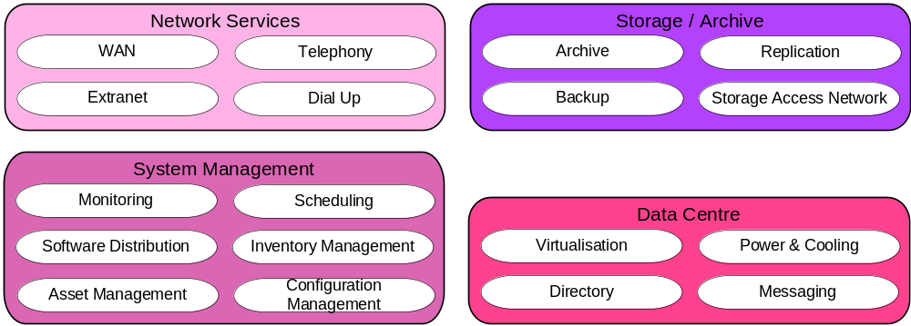

<Technology Architecture Conceptual Level View Description: This sub-section needs to provide a description of the conceptual level view(s) for the target Technology Architecture in order to understand the architectural decisions that have been taken and resulting key messages for the stakeholders.>

<Technology Architecture Conceptual Level Artifact Definitions: This sub-section needs to provide (in table format) definitions for the infrastructure services in scope for the target Technology Architecture.

Governance services: The services must cover the complete scope of the architecture, including governance and service management. Additional services can be identified by considering how the main services, when implemented, will be instantiated, started up, shut down, configured, monitored, and how faults will be diagnosed, users maintained, new business configuration items added (e.g. products) and so on. For more technical services, management functions such as provisioning, key management, identity management, backup, recovery, business continuity should be considered.>

Infrastructure Service Id | Infrastructure Service | Infrastructure Service Description

<Technology Architecture Conceptual Level Artifact Characteristics: This sub-section may need to provide (in table format) characteristics for the infrastructure services in scope for the target Technology Architecture. However, the domain will need to decide whether characteristics are needed at the conceptual services level, logical component level, or both levels. The domain also needs to determine which characteristics they wish to capture..>

Infrastructure Service | Infrastructure Service Characteristic | Infrastructure Service Characteristic Value

<Technology Architecture Logical Level Artifact Contracts: This sub-section may provide (in table format) descriptions of the contracts (i.e. interactions/relationships) between the logical infrastructure components in scope for the target Technology Architecture.>

CIS Contract Id | CIS Contract | Logical Infrastructure Component 1 | Logical Infrastructure Component 2 | LIC Contract Description

<Technology Architecture Conceptual Level Artifact Contract Characteristics: This sub-section may provide (in table format) characteristics of the contracts (i.e. interactions/relationships) between the Conceptual infrastructure services in scope for the target Technology Architecture. The domain needs to determine which characteristics they wish to capture.>

CIS Contract | CIS Contract Characteristic | CIS Contract Characteristic Value

Logical Target Technology Architecture

<Technology Architecture Logical Level Example: This sub-section needs to provide one or more logical level views for the target Technology Architecture. The diagram below provides a view of the target Technology Architecture at the logical level which consists of logical infrastructure components with their associated infrastructure services. This particular example illustrates some of the logical infrastructure components and associated infrastructure services within xxxxxx. However, the definition of logical infrastructure components can only be confirmed during the architectural analysis for each domain. Text describing the key concepts and notation used within the diagram will also need to be included so that users can easily read and understand the view.>

<Technology Architecture Logical Level View Description: This sub-section needs to provide a description of the logical level view(s) for the target Technology Architecture in order to understand the architectural decisions that have been taken and resulting key messages for the stakeholders.
More than one logical component architecture can be created by an architecture project, and then the different options evaluated and a recommended option chosen. If more than one option is considered, the document structure for the Logical Technology Architecture should be repeated for each option. In addition, a section to evaluate the options must be added and a section containing the recommendations. This applies to Unbranded and Branded Architectures.>
<Technology Architecture Logical Level Artifact Definitions: This sub-section needs to provide (in table format) definitions for the logical infrastructure components in scope for the target Technology Architecture.>

LIC Id | Logical Infrastructure Component (LIC) | Logical Infrastructure Component (LIC) Description

<Technology Architecture Logical Level Artifact Characteristics: This sub-section may need to provide (in table format) characteristics for the logical infrastructure components in scope for the target Technology Architecture. However, the domain will need to decide whether characteristics are needed at the conceptual services level, logical component level, or both levels. The domain also needs to determine which characteristics they wish to capture..>

Logical Infrastructure Component (LIC) | LIC Characteristic | LIC Characteristic Value

<Technology Architecture Logical Level Artifact Contracts: This sub-section may provide (in table format) descriptions of the contracts (i.e. interactions/relationships) between the logical infrastructure components in scope for the target Technology Architecture.>

LIC Contract Id | LIC Contract | Logical Infrastructure Component 1 | Logical Infrastructure Component 2 | LIC Contract Description

<Technology Architecture Logical Level Artifact Contract Characteristics: This sub-section may provide (in table format) characteristics of the contracts (i.e. interactions/relationships) between the logical infrastructure components in scope for the target Technology Architecture. The domain needs to determine which characteristics they wish to capture.>

LIC Contract | LIC Contract Characteristic | LIC Contract Characteristic Value

Physical Target Technology Architecture

<Technology Architecture Physical Level View Description: This sub-section can provide, if necessary, a description of the physical level view(s) for the target technology architecture in order to understand the architectural decisions that have been taken and resulting key messages for the stakeholders. This section should follow the same structure as the Logical Target Technology Architecture.>

Vendor Consideration List

<This section provides a list with relevant suppliers and brands for providing the physical components and the considerations for selecting or using them. >

Vendor/Product | Component | Considerations

Target Technology Architecture Cross Reference
<Technology Architecture Cross References: This section provides, if necessary some cross references for the technology architecture. The IS-TI services and components cross-references are included in the Application Architecture>

Security Architecture Models

Service Name | Description | Type | Target Specification: Policy Reference

Gap Analysis
<The purpose of this Gap Analysis section is to define the gap between the current (as-is) and target (to-be) state business architectures.

Mandatory/optional: This section is optional as not all the domain teams need to produce a business architecture for their respective domains. However, it can also be used by the domains that do not produce a full (current and target) or current state business architecture but still want to know the (priority) areas on which to concentrate, and thus minimise effort.

In terms of quality criteria, this section should make clear:
- Description of the gap between the current (as-is) and target (to-be) state business architectures. This difference, or delta, defines the scope of work that needs to be undertaken in order to transition from the current to the target business architecture. This scope is thus the scope of the programme(s) or project(s) that need to be completed in order to reach the target business architecture.

The suggested steps are as follows:
- Draw up a matrix with all the Architecture Building Blocks (ABBs) of the Baseline Architecture on the vertical axis, and all the ABBs of the Target Architecture on the horizontal axis.
- Add to the Baseline Architecture axis a final row labeled ‘‘New’’, and to the Target Architecture axis a final column labeled ‘‘Eliminated’’.
- Where an ABB is available in both the Baseline and Target Architectures, record this with‘‘Included’’ at the intersecting cell.
- Where an ABB from the Baseline Architecture is missing in the Target Architecture, each must be reviewed. If it was correctly eliminated, mark it as such in the appropriate ‘‘Eliminated’’ cell. If it was not, an accidental omission in the Target Architecture has been uncovered that must be addressed by reinstating the ABB in the next iteration of the architecture design — mark it as such in the appropriate ‘‘Eliminated’’ cell.
- Where an ABB from the Target Architecture cannot be found in the Baseline Architecture, mark it at the intersection with the ‘‘New’’ row as a gap that needs to filled, either by developing or procuring the building block.

When the exercise is complete, anything under ‘‘Eliminated’’ or ‘‘New’’ is a gap, which should either be explained as correctly eliminated, or marked as to be addressed by reinstating or
developing/procuring the function.

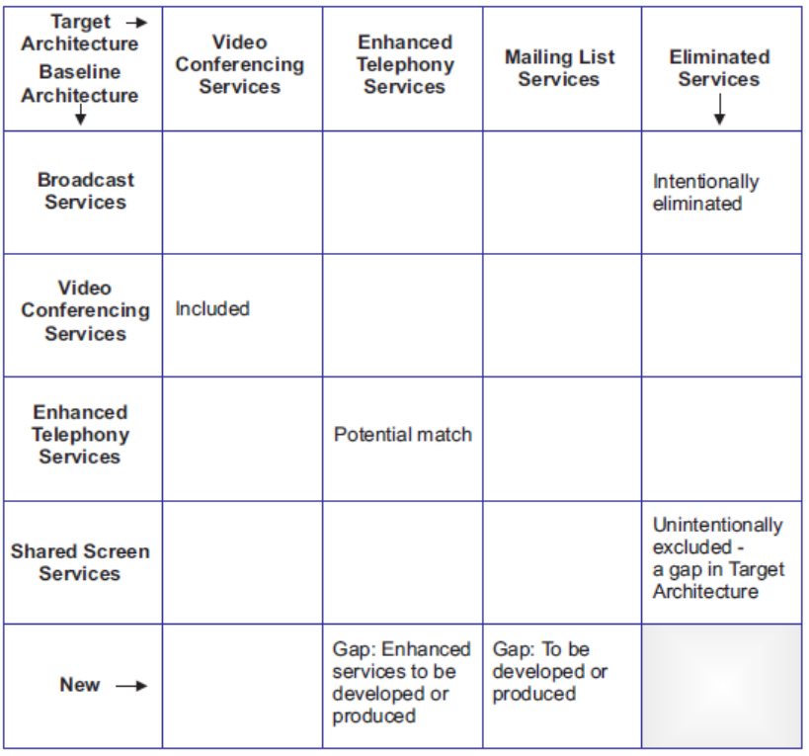>

Potential sources of gaps include:
- Business domain gaps:
  - People gaps (e.g., cross-training requirements)
  - Process gaps (e.g., process inefficiencies)
  - Tools gaps (e.g., duplicate or missing tool functionality)
  - Information gaps
  - Measurement gaps
  - Financial gaps
  - Facilities gaps (buildings, office space, etc.)
- Data domain gaps:
  - Data not of sufficient currency
  - Data not located where it is needed
  - Not the data that is needed
  - Data not available when needed
  - Data not created
  - Data not consumed
  - Data relationship gaps
- Applications impacted, eliminated, or created
- Technology impacted, eliminated, or created
>

Impact Assessment

<The purpose of this Impact Assessment section is to assess and document the impact (on the organisation) of the change required in order to transition from the current to the target state business architectures.

Mandatory/optional: This section is optional as not all the domain teams need to assess the organisational impact of change within their respective domains.

In terms of quality criteria, this section should make clear:
- Description of the organisational impact at a level that enables the organisation to determine the change management requirements for programme(s)/project(s).>

Reference to Specific Requirements

Stakeholder Priority of the Requirements to Date

Phases to be Revisited

Conclusions
<the purpose of this section is to draw conclusions about the architecture.
Mandatory/optional: This section is optional.
In terms of quality criteria, this section should make clear:
- Overall conclusions that can be drawn>

Recommendations
<the purpose of this section is make recommendations about the architecture.
Mandatory/optional: This section is optional.
In terms of quality criteria, this section should make clear:
- Recommendations for implementing this architecture.>

